**Practical No.01**

**Date:09/12/2024 Roll No.:01**

**Aim: Understanding the sensors node hardware (for example, sensors, nodes (sensor mote), Base Station, Graphical User Interface).**

**Wireless Sensor Network (WSN)**, is an infrastructure-less wireless network that is deployed in a large number of wireless sensors in an ad-hoc manner that is used to monitor the system, physical, or environmental conditions.

Sensor nodes are used in WSN with the onboard processor that manages and monitors the environment in a particular area. They are connected to the Base Station which acts as a processing unit in the WSN System. The base Station in a WSN System is connected through the Internet to share data. WSN can be used for processing, analysis, storage, and mining of the data.

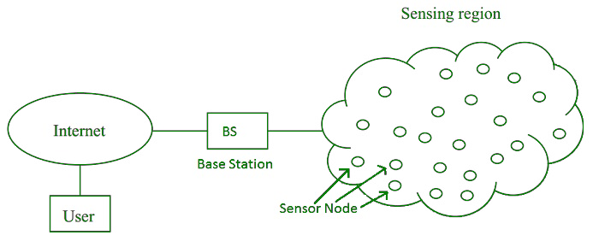

1. **Sensors:**

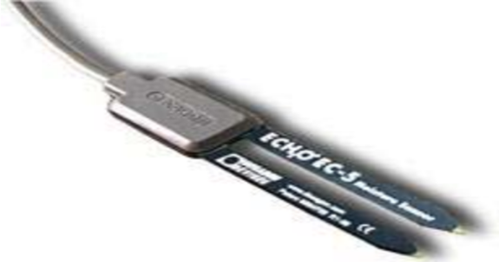

Sensors are the fundamental building blocks of Wireless Sensor Networks (WSNs).They are responsible for collecting data about the physical environment and transmitting it to a central location or other nodes within the network.

**Types of Sensors:**

WSNs can incorporate a wide variety of sensors to monitor diverse environmental parameters. Some common types include:

1. **Temperature Sensors:** Measure temperature variations.
2. **Humidity Sensors:** Monitor humidity levels.
3. **Pressure Sensors:** Detect changes in atmospheric or fluid pressure.
4. **Light Sensors:** Measure light intensity.
5. **Acoustic Sensors:** Detect sound and vibrations.
6. **Magnetic Sensors:** Detect magnetic fields.
7. **Chemical Sensors:** Detect specific gases or chemicals.
8. **Accelerometers:** Measure acceleration and shock.
9. **Gyroscopes:** Measure angular velocity and rotation.
10. **GPS Receivers:** Determine geographic location.

**Sensor Node Architecture:**

A typical sensor node in a WSN consists of the following components:

* **Sensor:** The primary component responsible for data acquisition.
* **Microcontroller:** Processes the sensor data, performs calculations, and controls the node's operations.
* **Transceiver:** Enables wireless communication with other nodes and the base station.
* **Power Source:** Typically a battery, although energy harvesting techniques can be used.
* **Memory:** Stores sensor data, program code, and configuration settings.

**Applications of WSNs**

WSNs have a wide range of applications, including:

* **Environmental Monitoring:** Tracking pollution levels, forest fires, and climate change.
* **Smart Agriculture:** Monitoring soil moisture, temperature, and crop health.
* **Healthcare:** Remote patient monitoring, elderly care, and disaster response.
* **Industrial Automation:** Monitoring machinery, inventory, and security.
* **Military and Defense:** Surveillance, target tracking, and battlefield awareness.

By understanding the role of sensors in WSNs, we can appreciate their potential to revolutionize various industries and improve our daily lives.

1. **Nodes (Sensor Mote):**

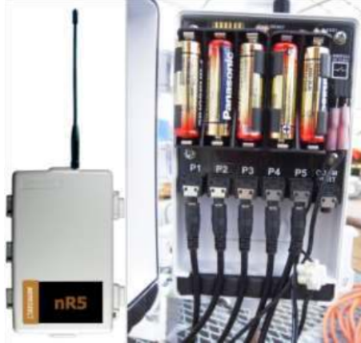

Sensor motes, also known as sensor nodes, are the fundamental building blocks of Wireless Sensor Networks (WSNs). These tiny devices are designed to collect data from their surroundings, process the information, and transmit it to a central location or other nodes within the network.

**Core Components of a Sensor Mote:**

1. Sensor: Captures environmental data (e.g., temperature, humidity).
2. Microcontroller: Processes data, manages operations, and communication.
3. Transceiver: Enables wireless communication (e.g., Zigbee, 802.15.4).
4. Power Source: Battery or energy harvesting (e.g., solar).
5. Memory: Stores data, programs, and configurations.

**Key Architectural Considerations:**

* Power Efficiency: Sensor motes are often deployed in remote locations with limited power sources. Energy-efficient hardware and software design are crucial.
* Wireless Communication: Reliable and efficient wireless communication is essential for data transmission.
* Robustness: Sensor motes must be able to withstand harsh environmental conditions, such as extreme temperatures, humidity, and vibrations.
* Security: Protecting sensor networks from cyberattacks is vital, especially in critical applications.

**Applications of Sensor Motes:**

* Environmental Monitoring: Tracking pollution levels, forest fires, and climate change.
* Smart Agriculture: Monitoring soil moisture, temperature, and crop health.
* Healthcare: Remote patient monitoring, elderly care, and disaster response.
* Industrial Automation: Monitoring machinery, inventory, and security.
* Military and Defense: Surveillance, target tracking, and battlefield awareness.

By understanding the architecture of sensor motes and the principles of WSNs, we can appreciate their potential to revolutionize various industries and improve our daily lives.

1. **Base Station**

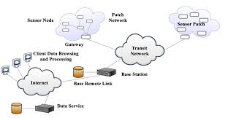

A **base station** in a WSN serves as the central node for communication and data aggregation. It collects data from multiple sensor nodes and processes or stores it locally. The base station often has higher computational power and a reliable power source compared to sensor nodes. It may forward the collected data to external systems via the internet or other networks. Additionally, it can send control commands to the sensor nodes for reconfiguration or task adjustments.

**Key Features of a Base Station in WSN:**

* **Data Collection:** Receives sensor data from nodes.
* **Data Processing:** Processes raw data to extract meaningful information.
* **Data Storage:** Stores collected data for analysis and retrieval.
* **Data Transmission:** Transmits processed data to external systems.
* **Network Management:** Manages network topology, node activities, and optimization.
* **Security:** Implements security measures to protect the network.

**Applications of Base Stations in WSN:**

* **Environmental Monitoring:** Tracking pollution, climate change, and natural disasters.
* **Smart Agriculture:** Monitoring soil moisture, temperature, and crop health.
* **Healthcare:** Remote patient monitoring and elderly care.
* **Industrial Automation:** Monitoring machinery and inventory.
* **Military and Defense:** Surveillance, target tracking, and battlefield awareness.

**Architecture of a Base Station in WSN:**

A base station in a WSN typically consists of the following components:

1. **Transceiver:** Enables wireless communication with sensor nodes.
2. **Processor:** Processes data, performs calculations, and manages the network.
3. **Memory:** Stores data, program code, and configuration settings.
4. **Power Supply:** Ensures continuous operation.
5. **Network Interface:** Connects the base station to a larger network.

**Key Architectural Considerations:**

* **Data Processing Capabilities:** Handle large data volumes and complex analysis.
* **Network Management:** Efficiently manage network resources and optimize performance.
* **Security:** Implement strong security measures to protect the network.
* **Scalability:** Accommodate growing number of nodes and data rates.
* **Reliability:** Ensure continuous operation and data collection.

1. **Graphical User Interface**

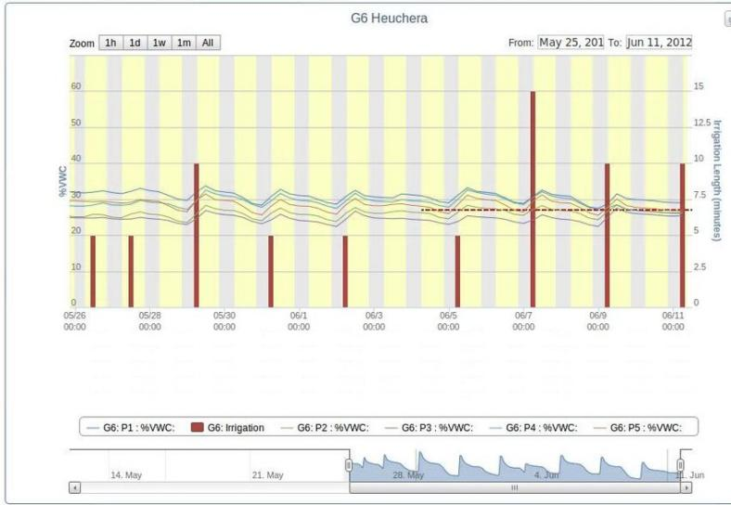

A GUI makes WSNs user-friendly. It allows you to:

* **See sensor data** in real-time (e.g., temperature, humidity).
* **Control sensors** remotely.
* **Get alerts** for important events (e.g., high temperature).
* **Store data** for future analysis.

**Key applications:**

* **Environmental monitoring:** Track pollution, climate change.
* **Smart agriculture:** Monitor crops, soil.
* **Healthcare:** Monitor patient health remotely.
* **Industry:** Monitor machines, inventory.

**Architecture of a GUI in WSN**

A typical GUI architecture for a WSN involves the following components:

1. **Sensor Nodes:** Collect data from the environment and transmit it to the base station.
2. **Base Station:** Receives data from sensor nodes, processes it, and sends it to the GUI.
3. **GUI Client:** The user interface that displays sensor data, provides controls, and allows user interaction.
4. **Communication Protocol:** The protocol used for communication between sensor nodes, base station, and GUI (e.g., MQTT, CoAP, HTTP).
5. **Data Storage:** Stores historical data for analysis and future reference.

By providing a user-friendly interface, GUIs enhance the usability of WSNs and enable better decision-making based on real-time data.

**Practical No.02**

**Date:08/01/2025 Roll No.:01**

**Aim: Understanding, reading and analyzing routing table of network.**

**Step 1: Take 5 routers.**

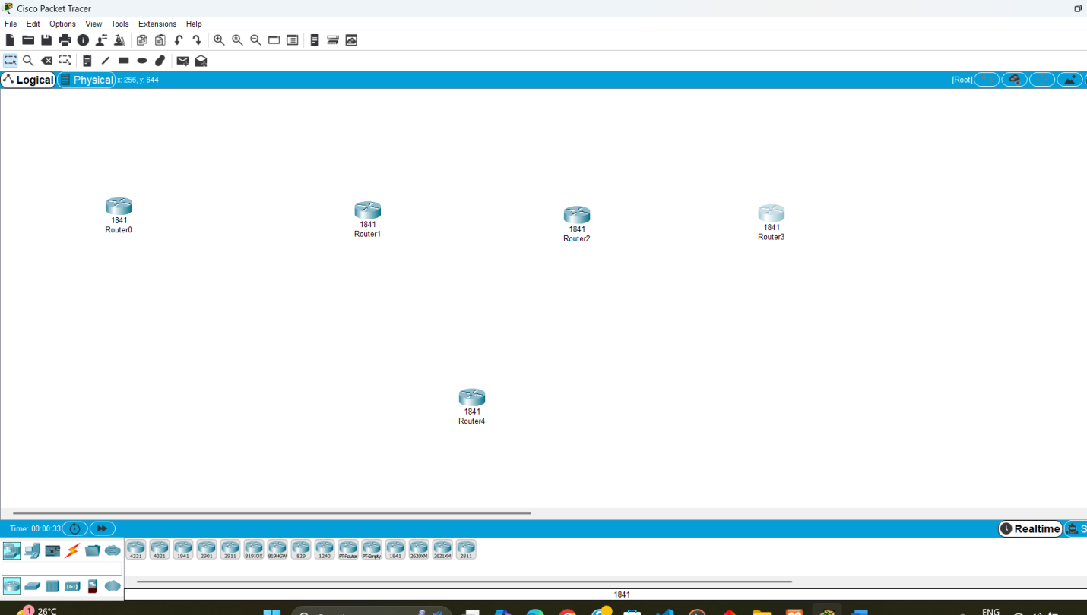

**Step 2: Connect the routers using wire Copper Cross Over.**

**Connecting router 0 to router 1 by FastEthernet 0/0**

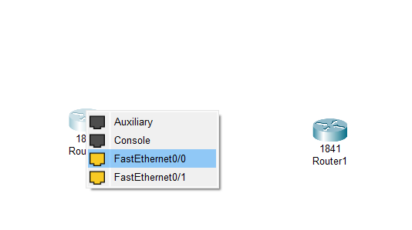 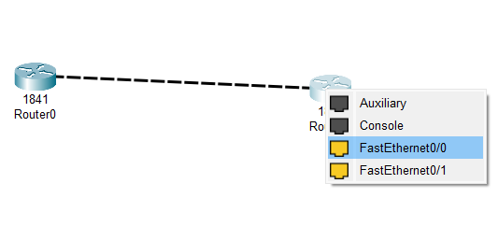

**Connecting router 1 to router 2 by FastEthernet 0/1**

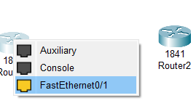 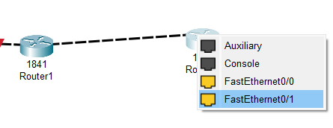

**Connecting router 2 to router 3 by FastEthernet 0/0**

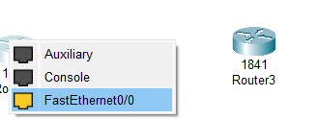 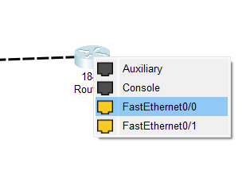

**Step 3: Add Serial Interface to Router 1**

**Switch off the router and add WIC 2T serial interface.**

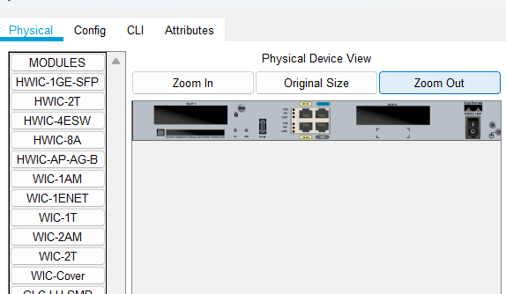 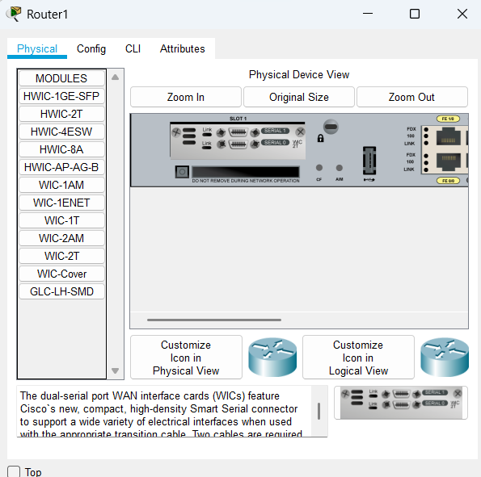

**After that turn on the router.**

**Do the same thing withn router 4**

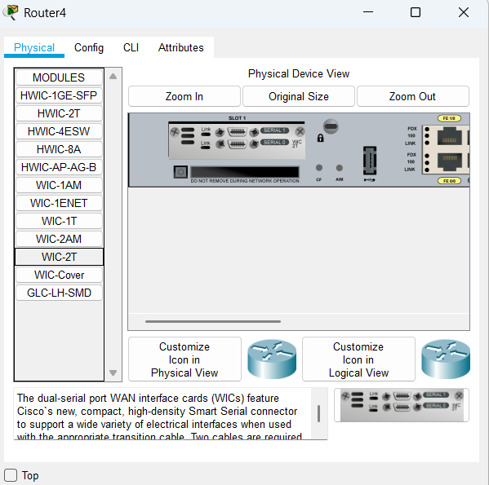

**Step 4: Connect Router 1 to Router 4 by using Serial DTE by Serial 0/1/0**

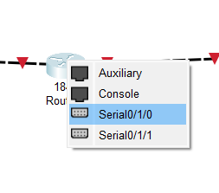 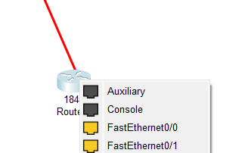 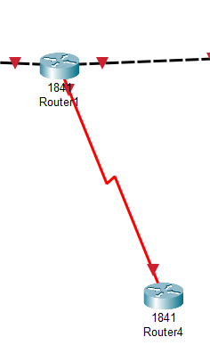

**Step 5: Now we add ip addresses. We configure the routers using the IP addresses.**

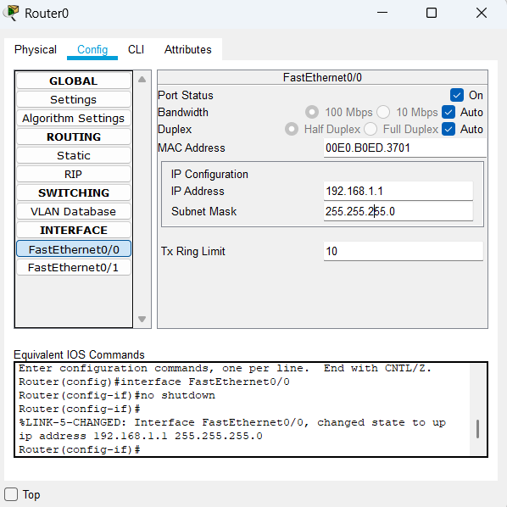

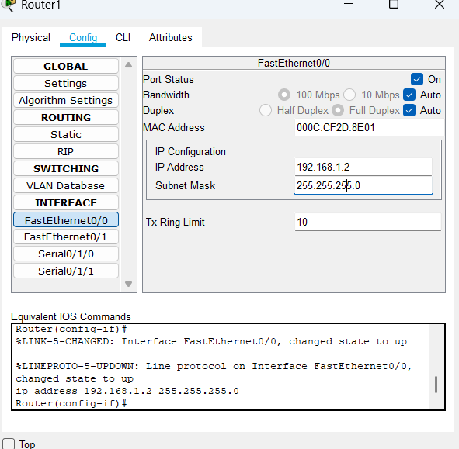 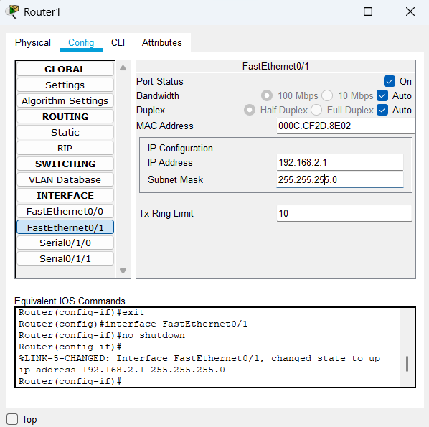

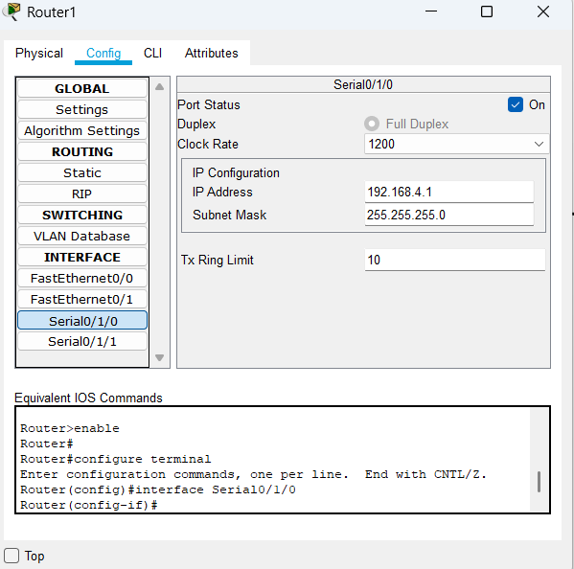 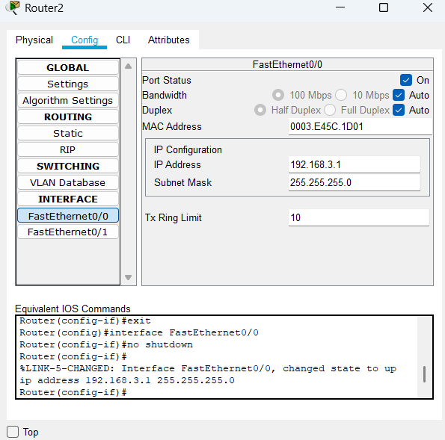

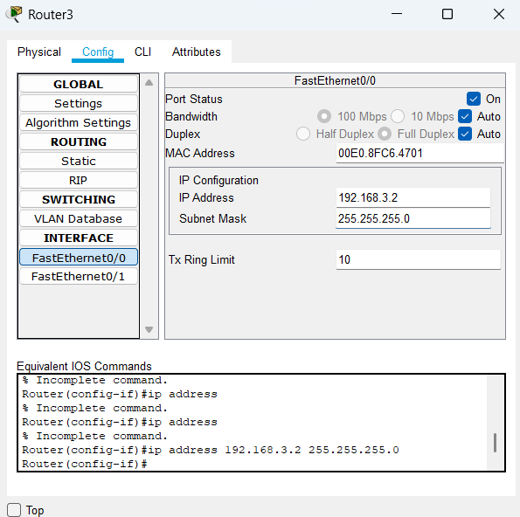 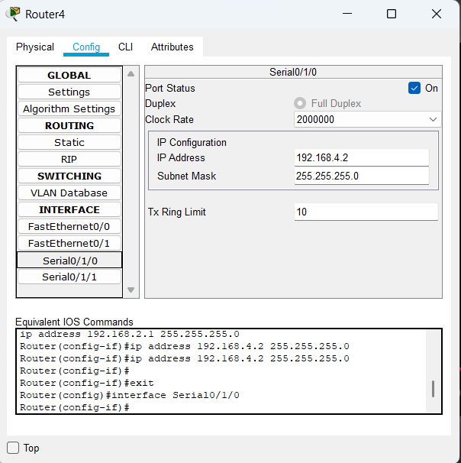

**Step 6: Set the routing path for all the router.**

**In router 0 add 192.168.1.0**

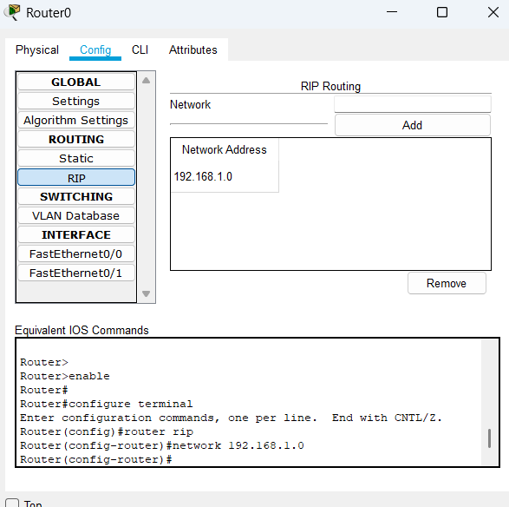

**In router 1 add address**

**192.168.1.0**

**192.168.2.0**

**192.168.4.0**

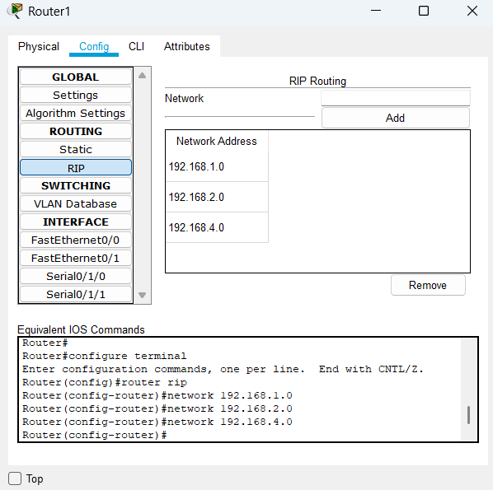

**In router 2 add**

**192.168.2.0**

**192.168.3.0**

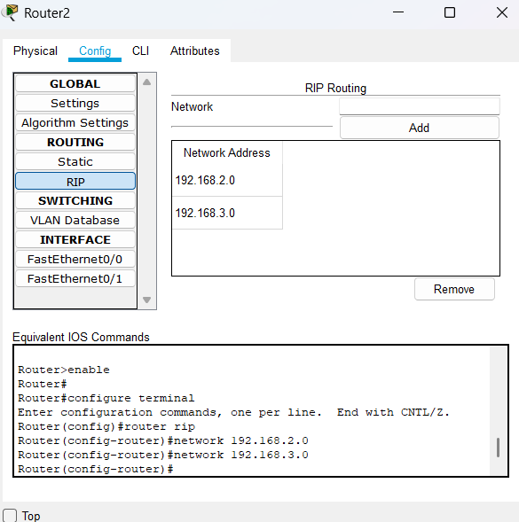

**In router 3 add**

**192.168.3.0**

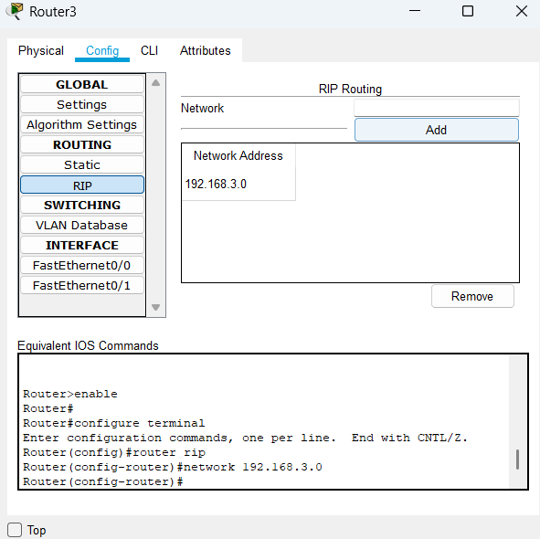

**In router 4 add**

**192.168.4.0**

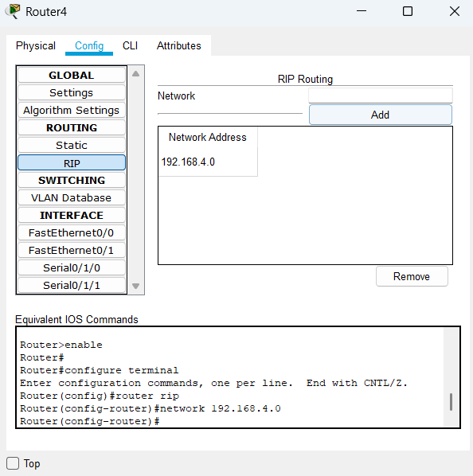

**Step 7: To check the routing path, we select Router 1 and type the followig command in CLI mode**

**Go to router 1**

**Type command ‘show ip route’**

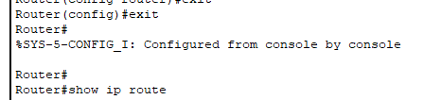

**It will show all the routing table.**

**This information is stored in the Routing table of Router 1 Which is the given network.**

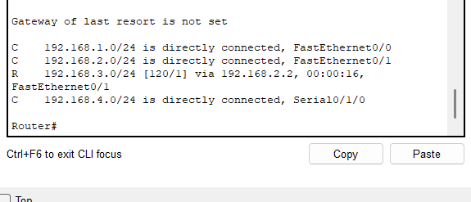

**Practical No.03**

**Date:13/01/2025 Roll No.:01**

**Aim: Implement a Wireless Sensor Network simulation.**

**Step 1:** Create the following network using AccessPoint-PT-A and PC-PT.

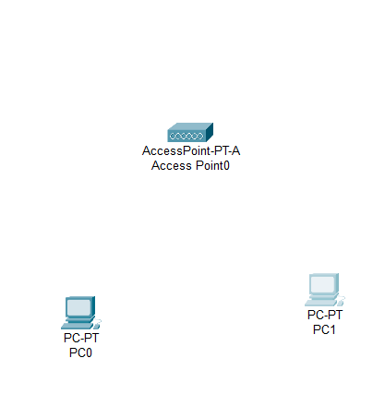

**Step 2:** Click on CPU and remove the FastEthernet module and install PT-HOST-NM-1W-A and turn on the CPU.

**Step 3:** A connection will be made between Accesspoint and PC0.

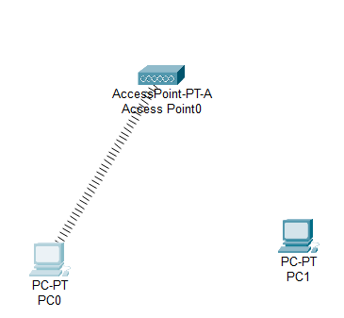

**Step 5:** Click on PC1 and click on Physical tab.

**Step 6:** Repeat step 3 and see if the connection is done between PC1 and Accesspoint.

**Step 7:** Click on PC0 and PC1 and set the IP config.

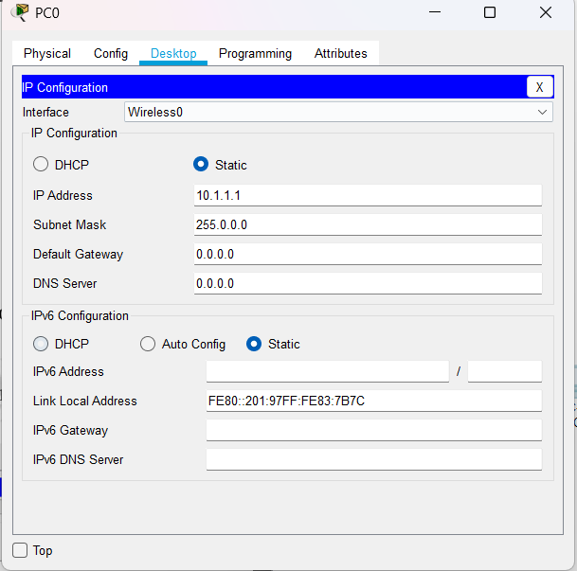 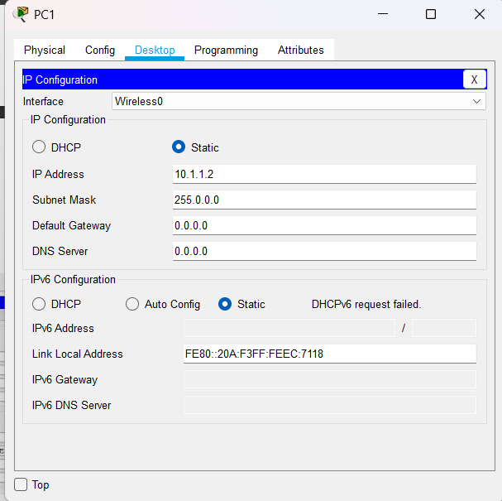

Step 8: Test Access Point A

* 1. Ping PC1(10.1.1.1) from PC0. The ping should succeed.

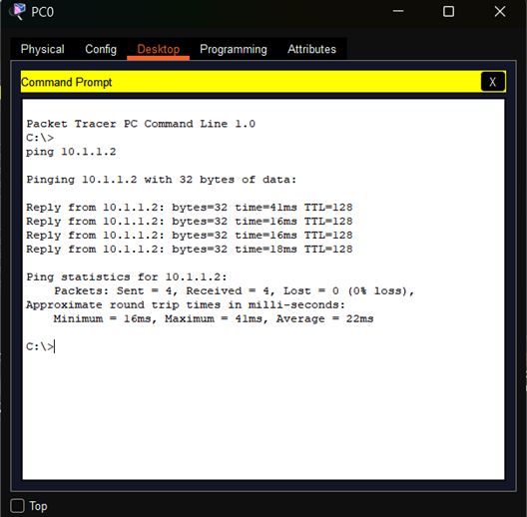

* 1. Ping Laptop0 (10.1.1.3) and Server0(10.1.1.4) from PC0. The Pings should fail.

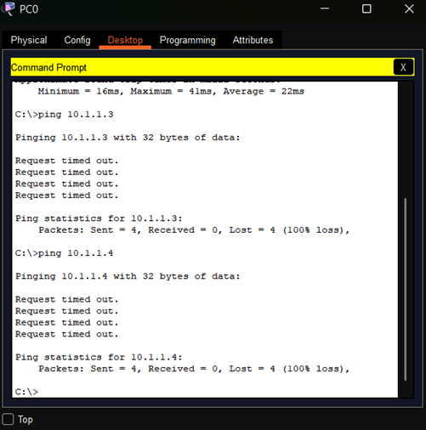

**Step 10:** Create a network using Accesspoint-PT, Accesspoint-PT-N, Laptop and Server.

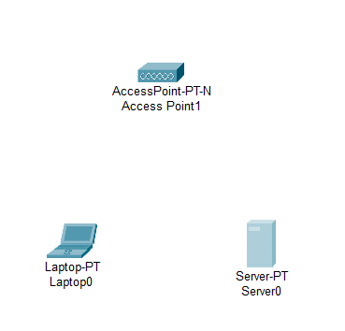

**Step 11:** Click on Laptop and click on Physical tab.

**Step 12:** Turn off the Laptop and remove the PT-LAPTOP-NM-1CEF module and install PT-LAPTOP-NM-1W and turn on the Laptop

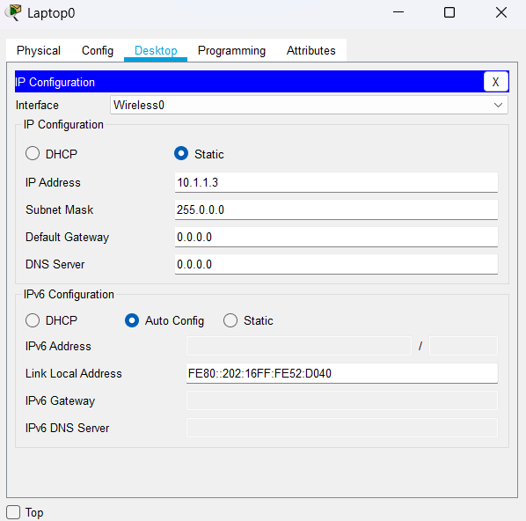 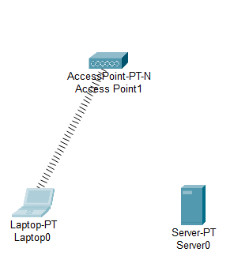

**Step 15:** Click on Server on Physical tab.

**Step 16:** Turn Off the Server and remove the PT-HOST-NM-1W and turn on the server.

**Step 17:** A connection will be made between Accesspoint-PT-N and Server.

**Step 18:** Click on Server and set the IP config.

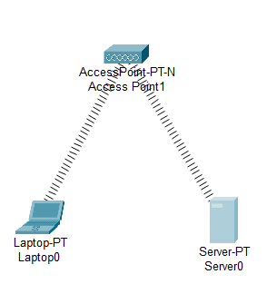 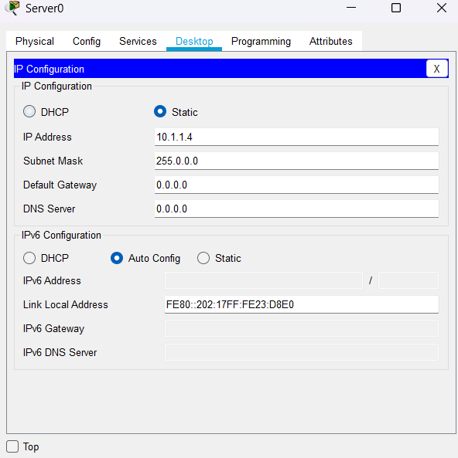

**Step 19:** Test Accesspoint N

* 1. Ping Server0 (10.1.1.4) from Laptop0. The ping should succeed.
  2. Ping PC0 (10.1.1.1) and PC1 from Laptop0. The Pings should fail.

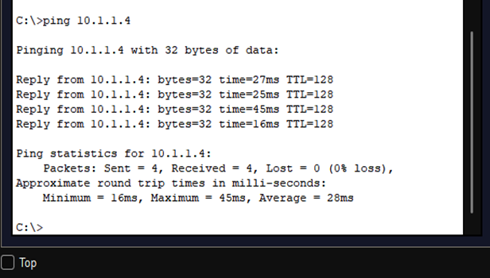

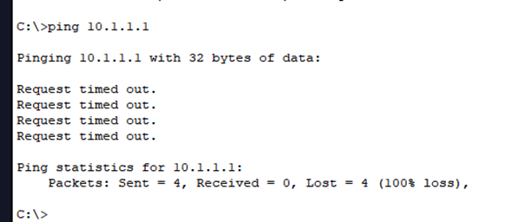

**Step 20:** Now turn off the port of AccesspointN and Test Access Point_B_G.

* 1. Turn on Port1 on Access Point_B_G and turn off Port1 on Access PointN. Laptop0 and Server0 should associate with Access Point_B_G.

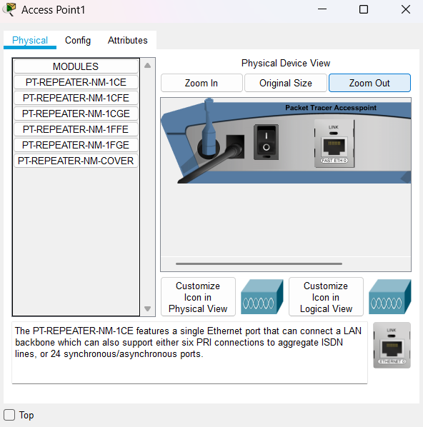 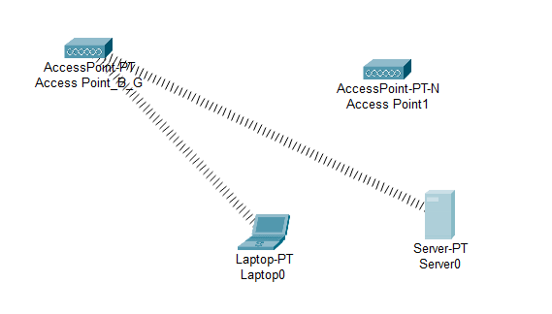

* 1. Ping Server0 (10.1.1.4) from Laptop0. The Ping should succeed.

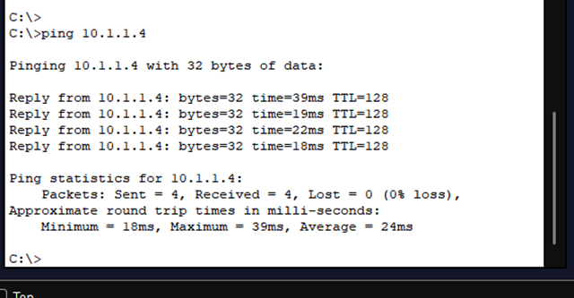

**Practical No.04**

**Date:20/01/2025 Roll No.:01**

**Aim: Create MAC protocol simulation implementation for wireless sensor Network.**

**Step 1:** Create the Network.

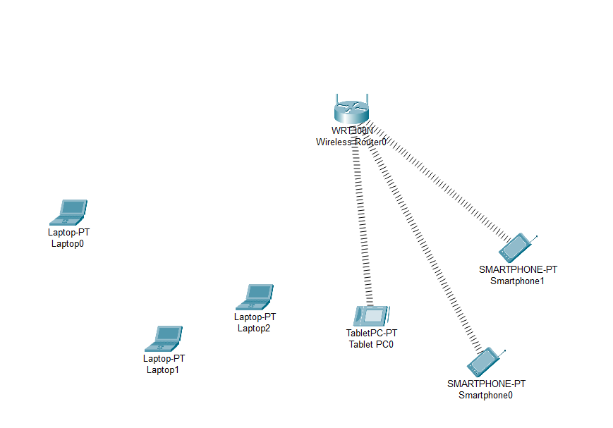

**Step 2:** Click on every laptop and change the interface to PT-LAPTOP-NM-1W.

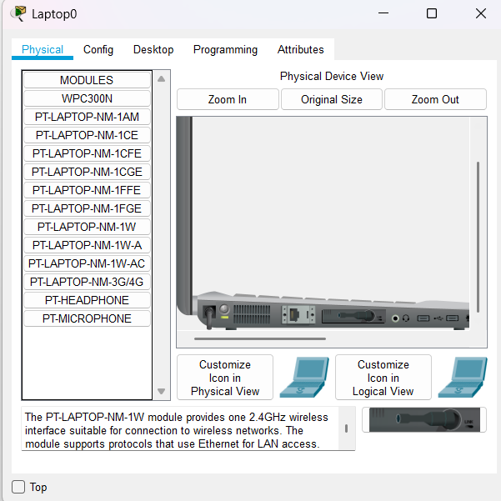 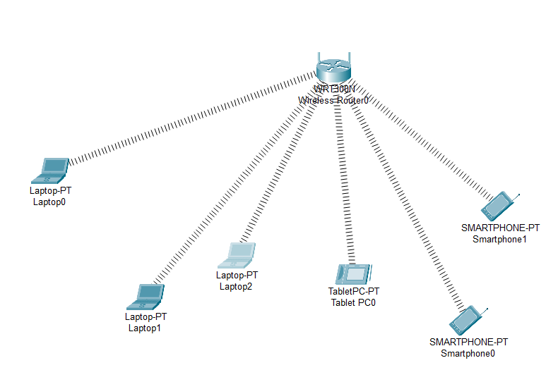

**Step 3:** Copy the MAC address of each component as follows.

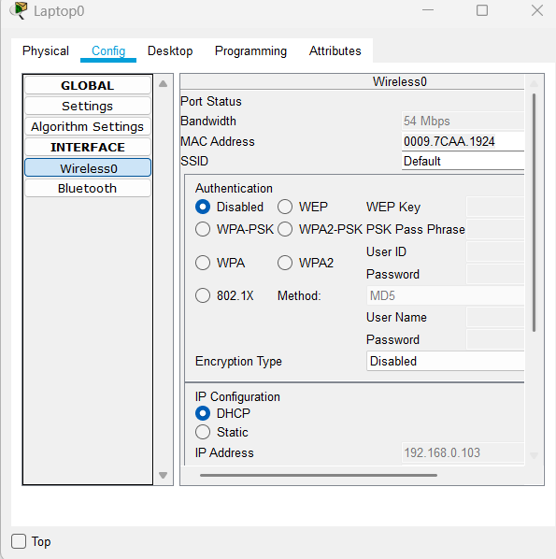 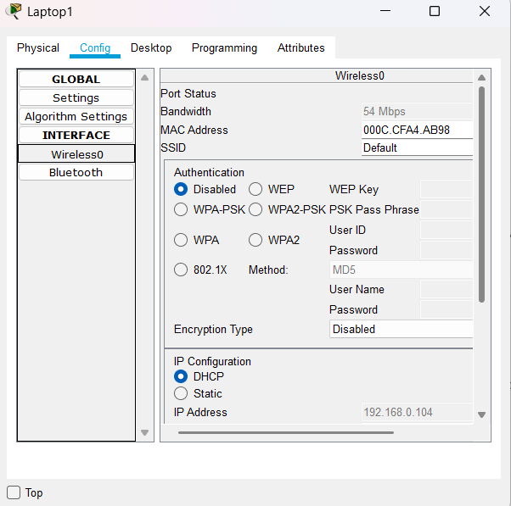

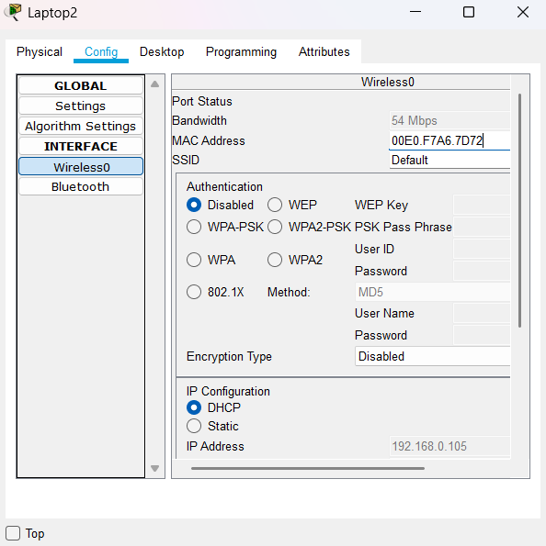 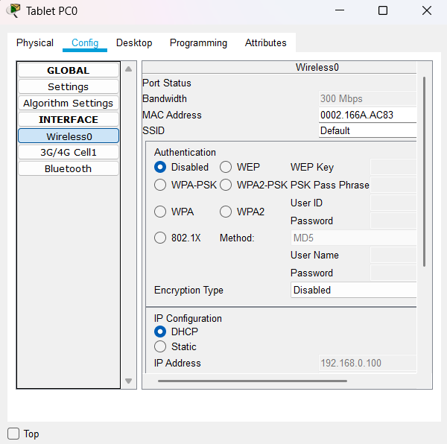

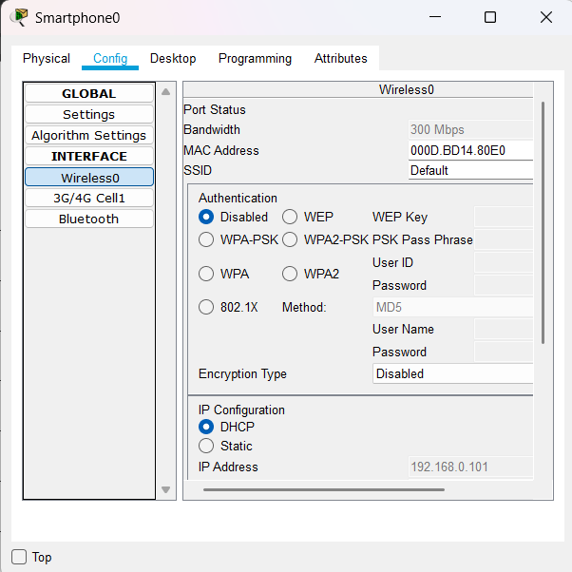 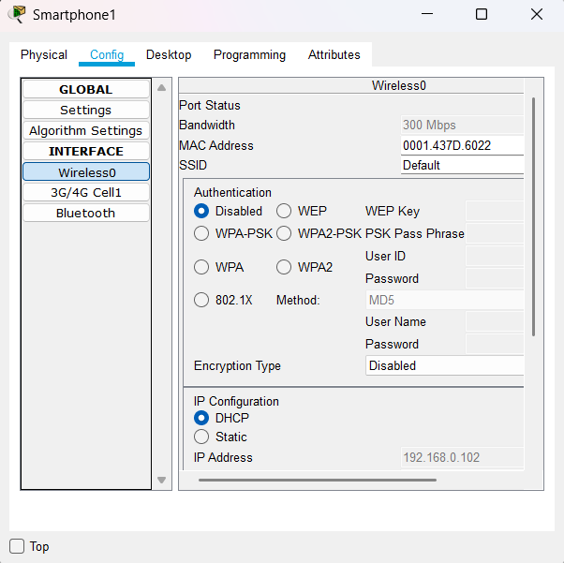

|  |  |  |
| --- | --- | --- |
| **Component** | **MAC Address** | **Converted MAC Address** |
| Laptop0 | 0009.7CAA.1924 | 00:09:7C:AA:19:24 |
| Laptop1 | 000C.CFA4.AB98 | 00:0C:CF:A4:AB:98 |
| Laptop2 | 00E0.F7A6.7D72 | 00:E0:F7:A6:7D:72 |
| TabletPC | 0002.166A.AC83 | 00:02:16:6A:AC:83 |
| SmartPhone0 | 000D.BD14.80E0 | 00:0D:BD:14:80:E0 |
| SmartPhone1 | 0001.437D.6022 | 00:01:43:7D:60:22 |

**Step 4:** Now we add few addresses in the wireless MAC filter of the Wireless Router and then use the given options for either allow or deny the Wireless access.

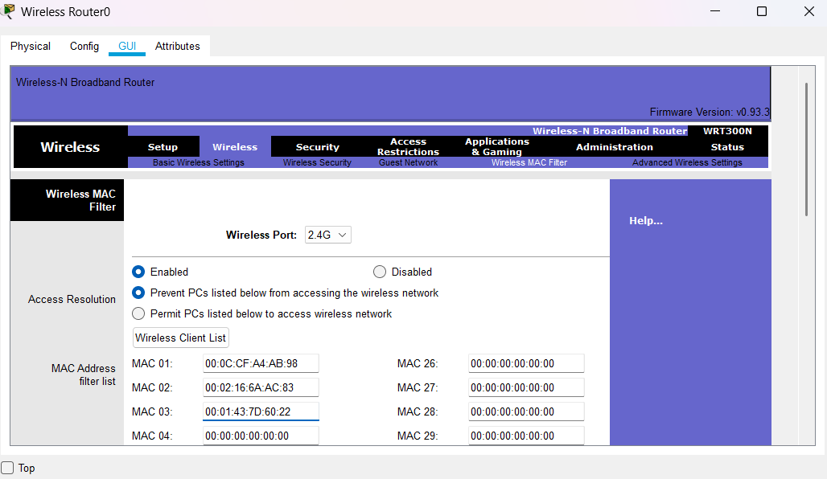

**Step 5:** As seen in above screen shot we add the MAC address of Laptop0, Laptop2 and SmartPhone0 in the list so as to deny them accessing the Wireless network and then save the settings.

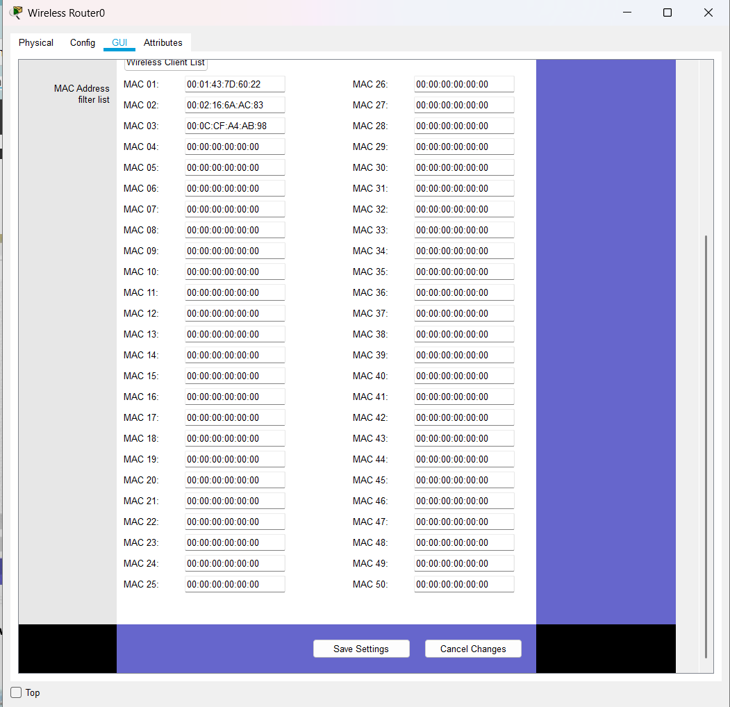

The result so obtained is as shown, the three devices denied any wireless connectivity.

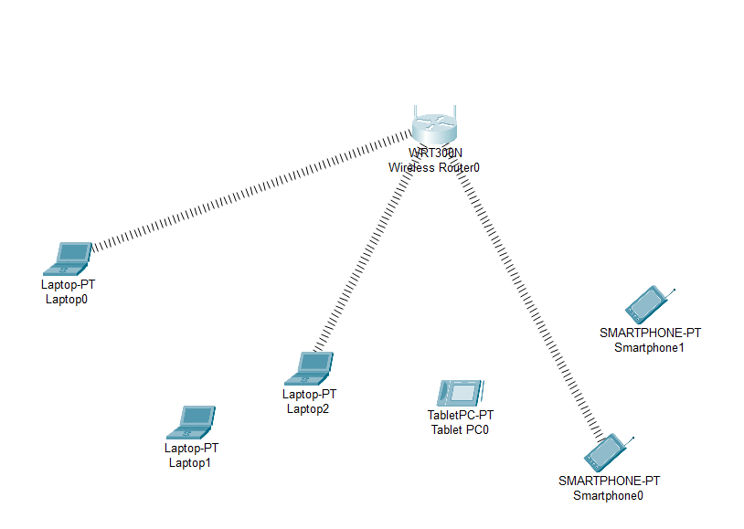

**Step 6:** Similarly, we can change the setting so that the above devices get wireless connectivity and the remaining devices do not get the wireless connectivity.

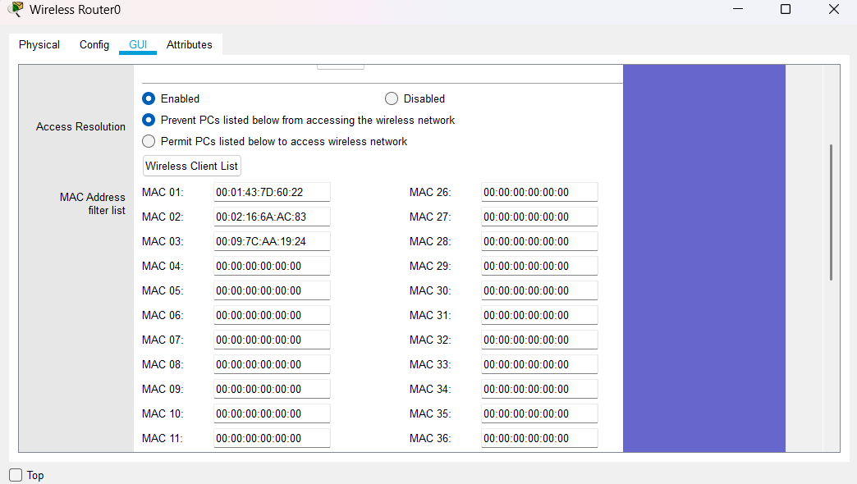

**Step 7:** And save the setting and get the following.

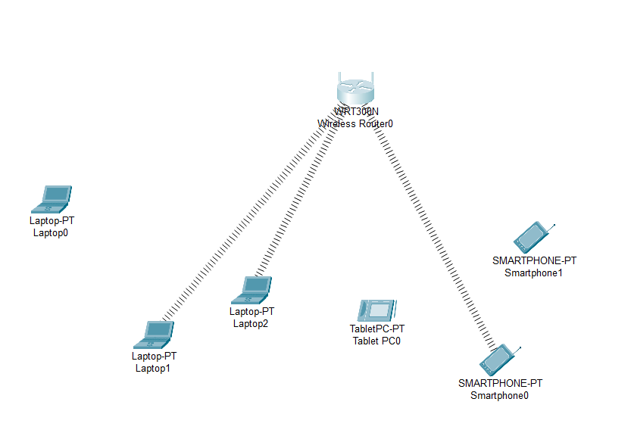

**Practical No.05**

**Date:27/01/2025 Roll No.:01**

**Aim: Simulate Mobile Adhoc Network with Directional Antenna.**

**Step 1:** Create the following network.

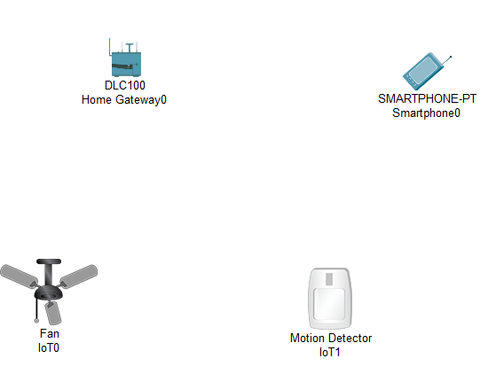

**Step 2:**Click on the Fan do the following.

1. Go to Config select Gateway/DNS IPV4 as DHCP, Gateway/DNS IPV6 as DHCP, and IoT Server as Home Gateway.

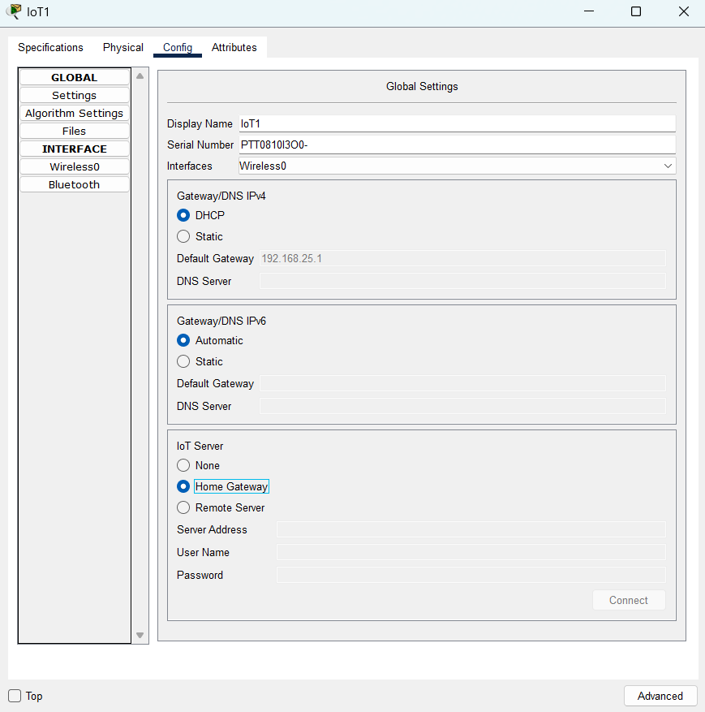

1. In the Advanced setting do the following for the Network adapter.

Go to Advanced-I/O Config-Network Adapter and change it as PT-IOT-NM-1W

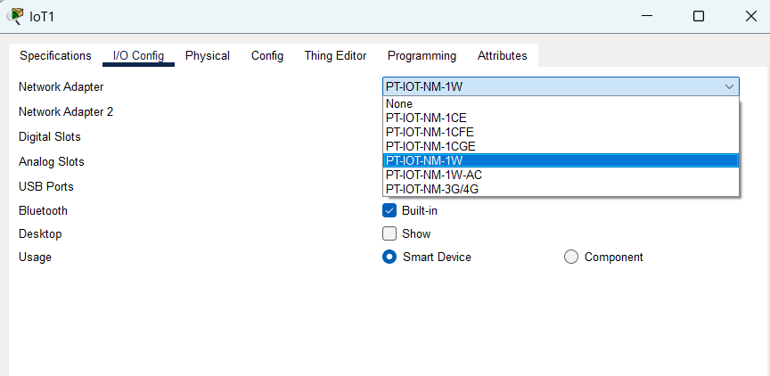

1. For the Motion Detector Sensor do the following.

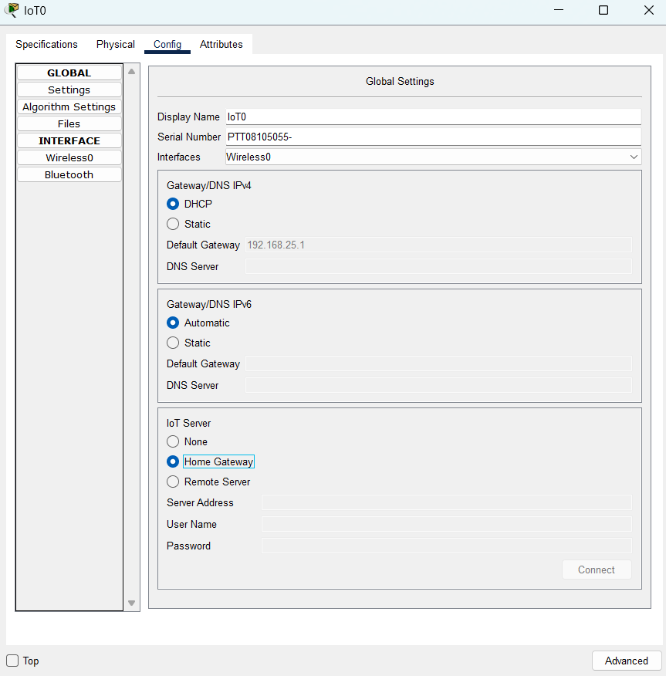

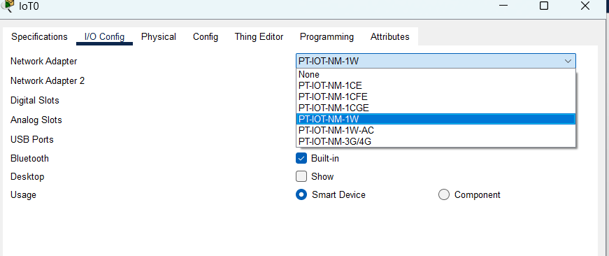

**Step 2:**For the Smartphone change the SSID to the SSID in the Home Gateway0

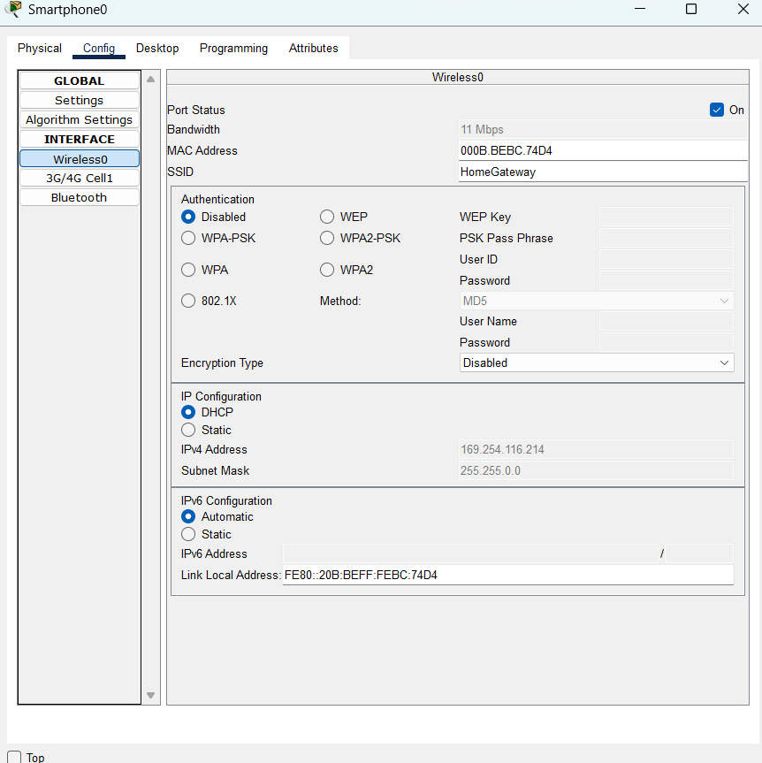

**Step 3:**As seen above the SSID is HomeGateway, we use the same and set the SSID in the Smartphone.



**Step 4:**All the devices are now connected to the Home Gateway.

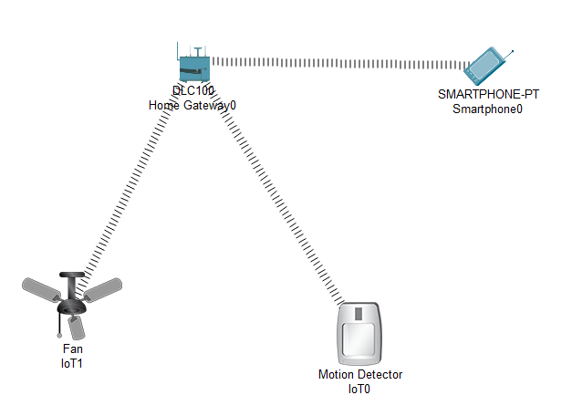

**Step 5:**Now open the Web Browser of the SmartPhone and type the IP address of the HomeGateway

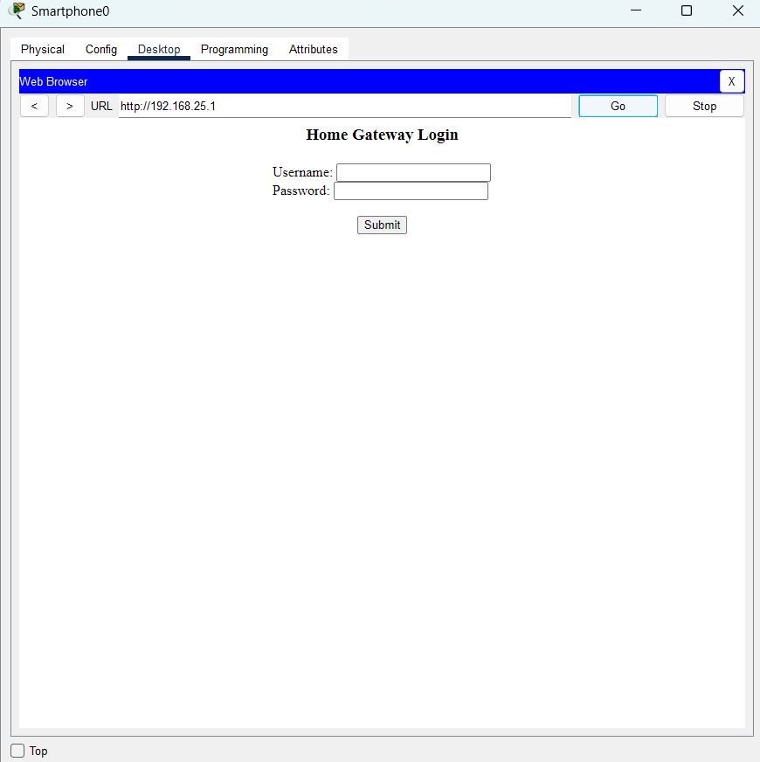

Username: admin

Password: admin

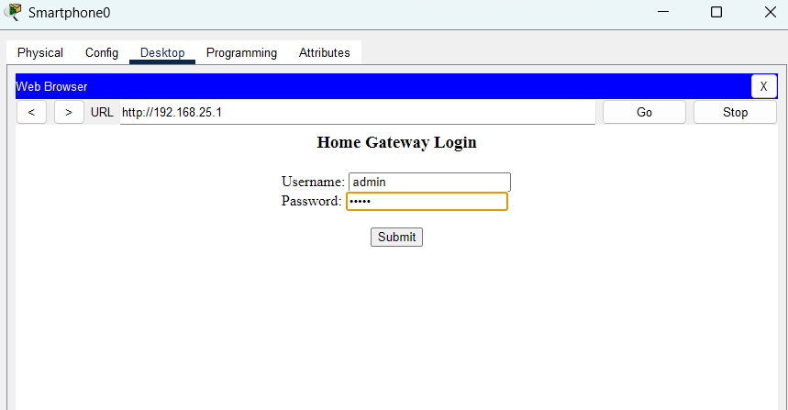

**Step 6:** After logging click on conditions and do the following.

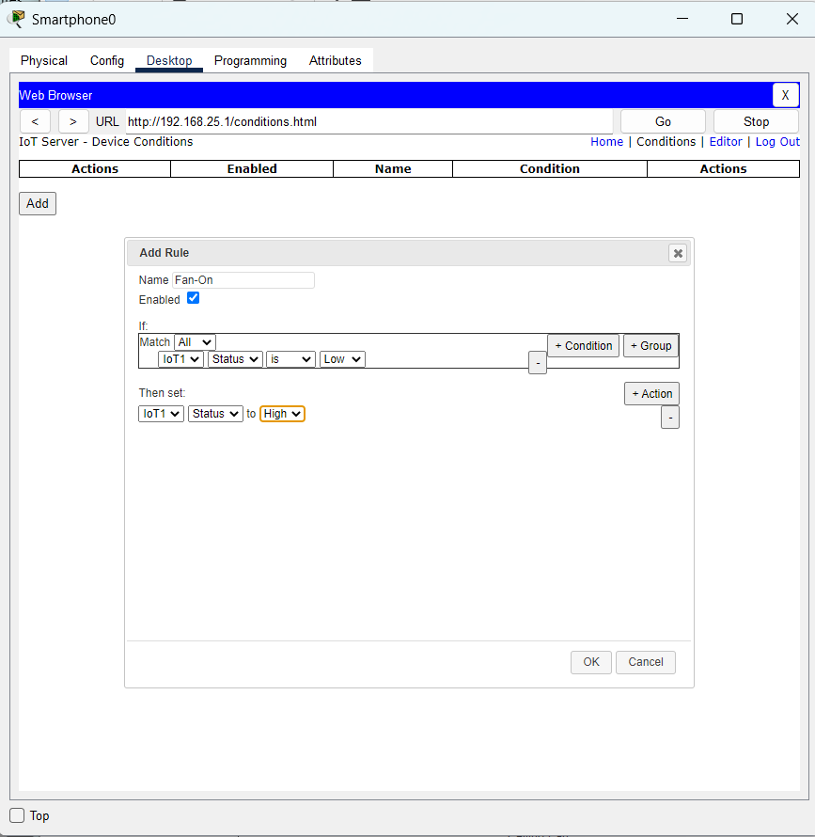

**Step 7:** Add another condition as follows.

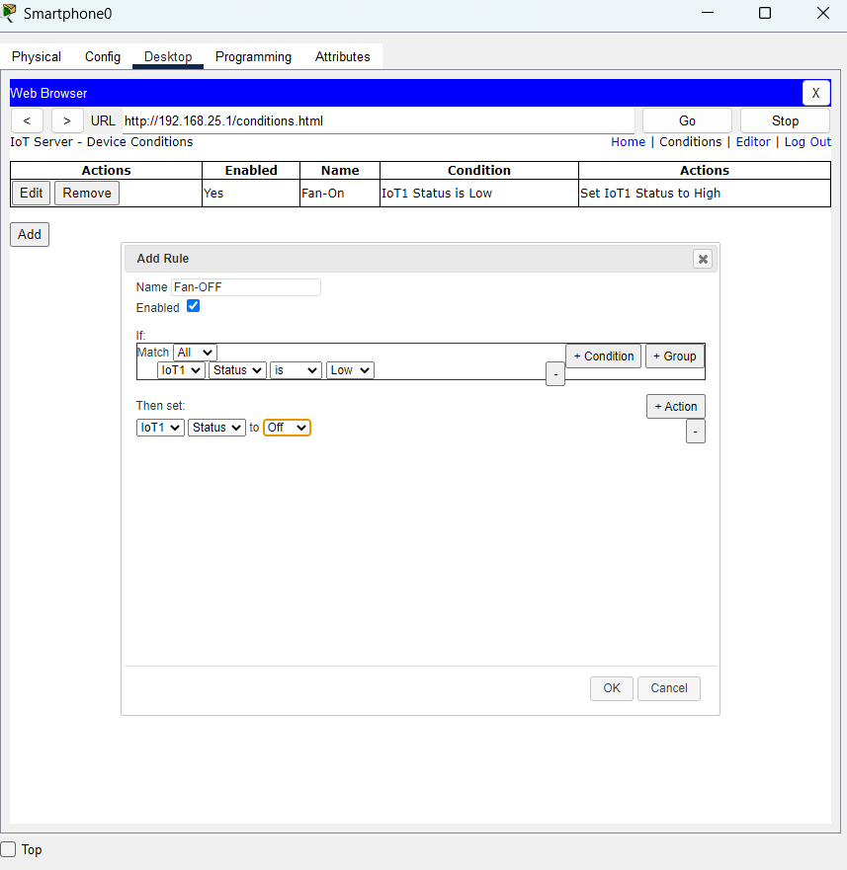

**Step 8:** Press the go button after adding the two conditions.

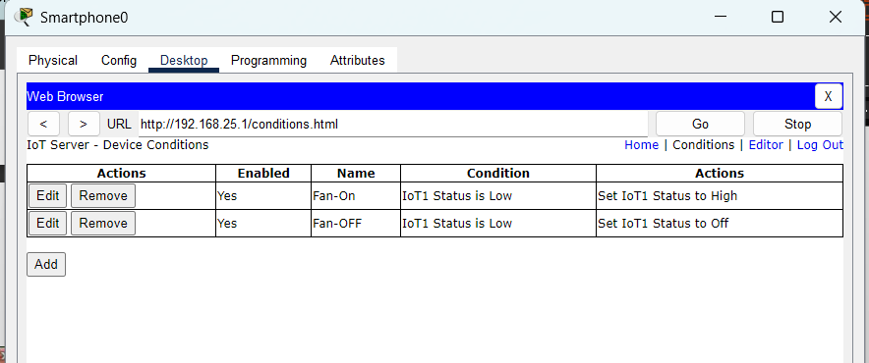

**Step 9:** In order to turn ON the fan Press the ALT key and left-click the mouse over the Sensor.

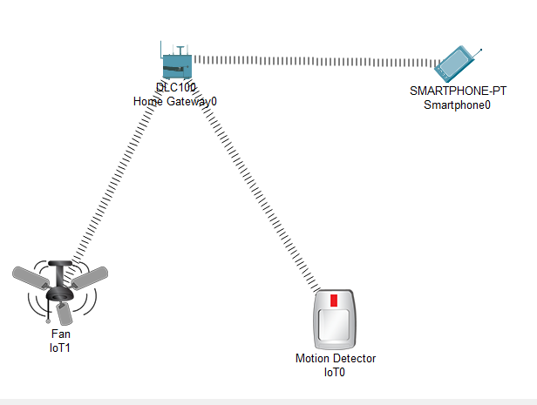

**Practical No.06**

**Date:03/02/2025 Roll No.:16**

**Aim: Create a mobile network using Cell Tower, Central Office Server, web browser, and Web Server. Simulate connection between them.**

**Steps:**

1. Create a network using smartphone, wireless router WRT300N, Hub-pt, 1841 Router, central-office server, Cell-Tower.

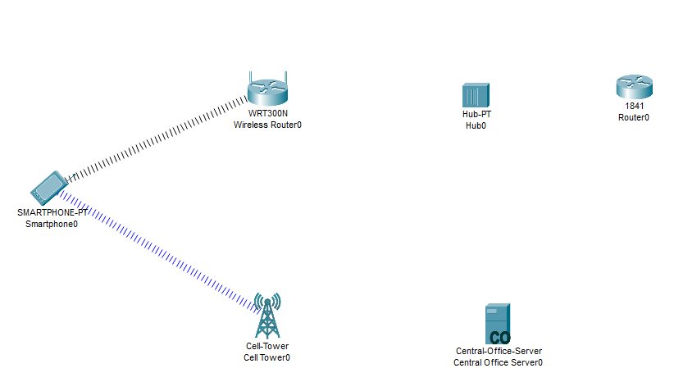

1. Connect cell tower and central office server using coaxial cable.
2. Connect wireless router WRT300N, Hub-pt, 1841 Router, central-office-server using copper straight through wire.

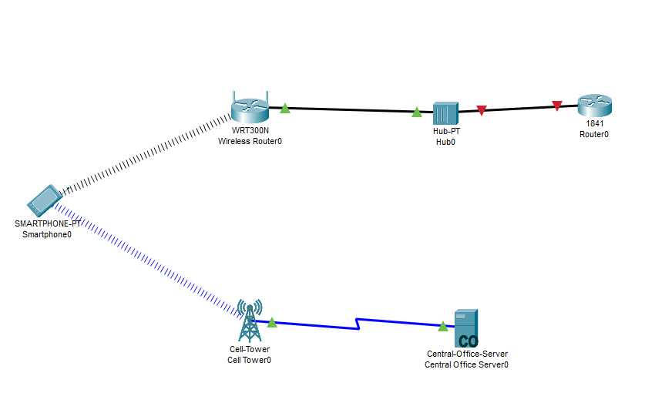

1. Click on wireless router in config tab select internet.in internet choose ip configuration as static and set IP address and default gateway.

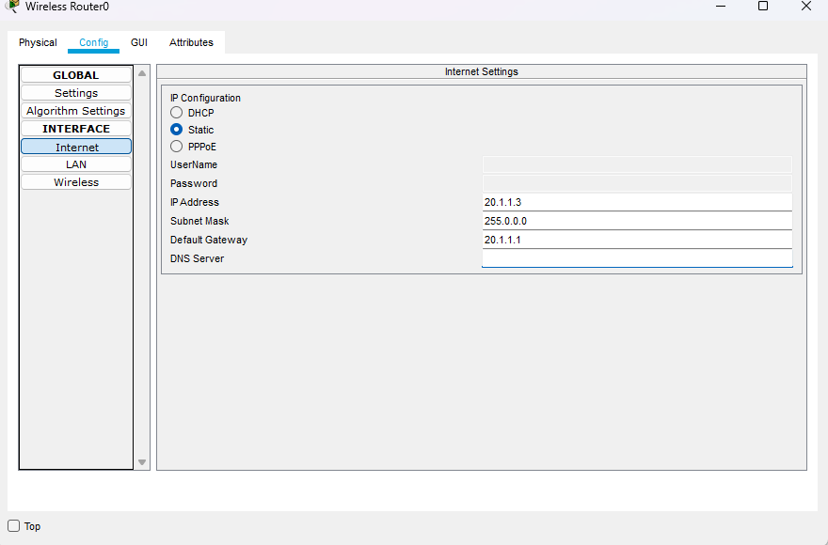

1. Click on router 1841. In config tab select interface and select IP address.

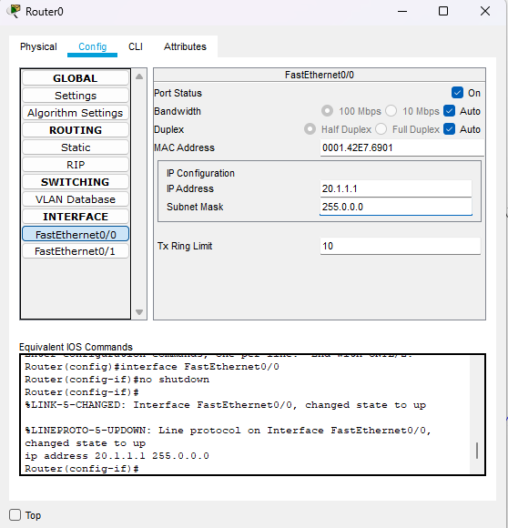

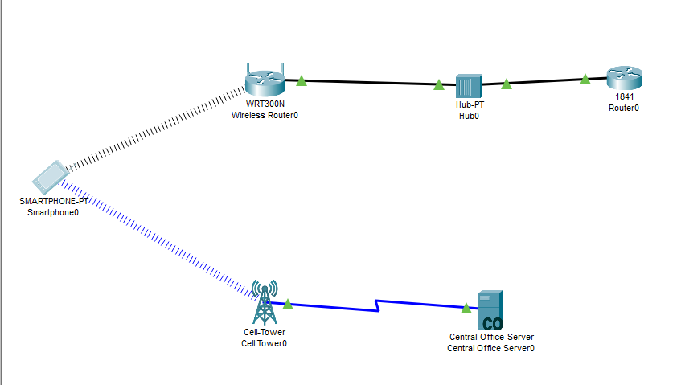

1. Click on smartphone and ping router 1841(ping 20.1.1.1).

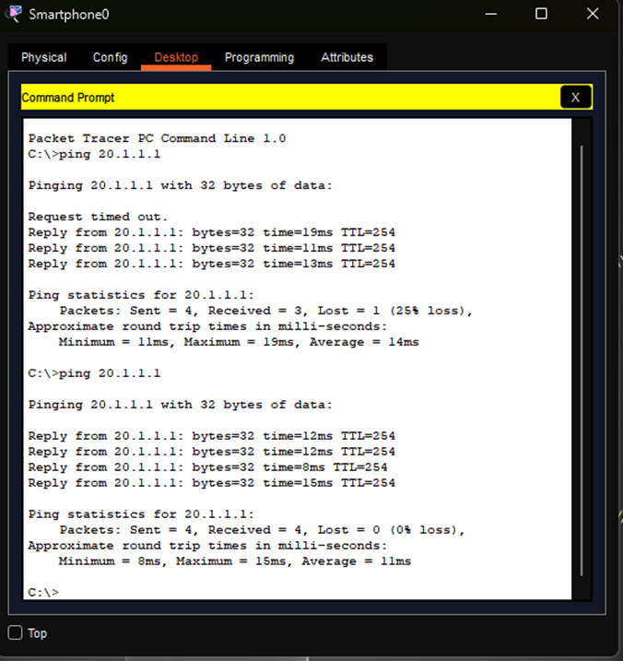

**Practical No.07**

**Date: Roll No.:16**

**Aim: simulate directional antenna with the help of a home automation system**

**Steps:**

1. First, we take all the components we need

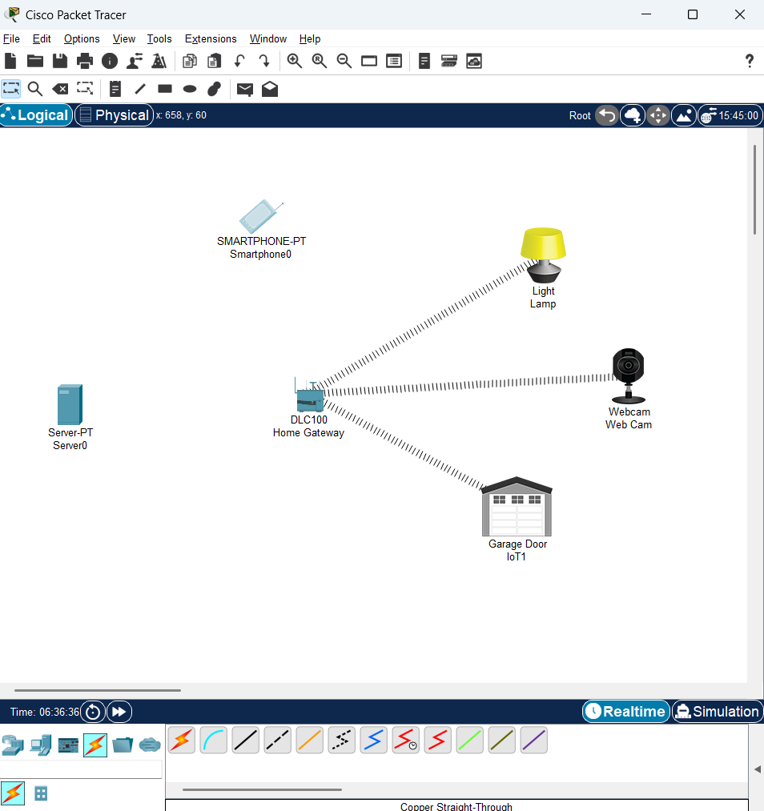

All devices are connected automatically but the smart phone is not.

We will connect the smartphone to the Home Gateway

1. We click on home Gateway 🡪 config 🡪 wireless and copy the SSID

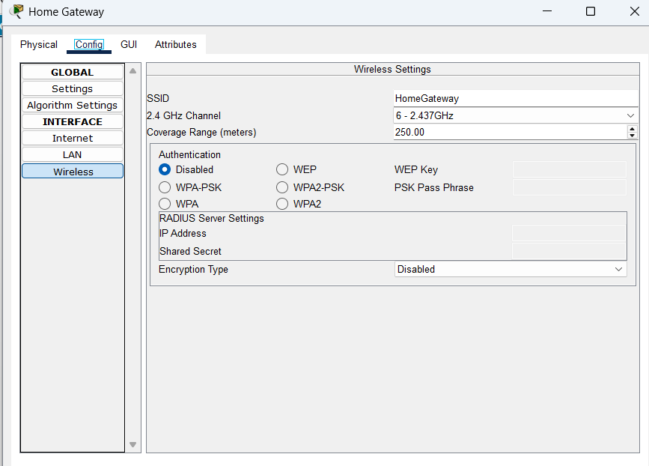

1. And then click on Smart Phone 🡪 config 🡪 wireless 0 and then past the SSID

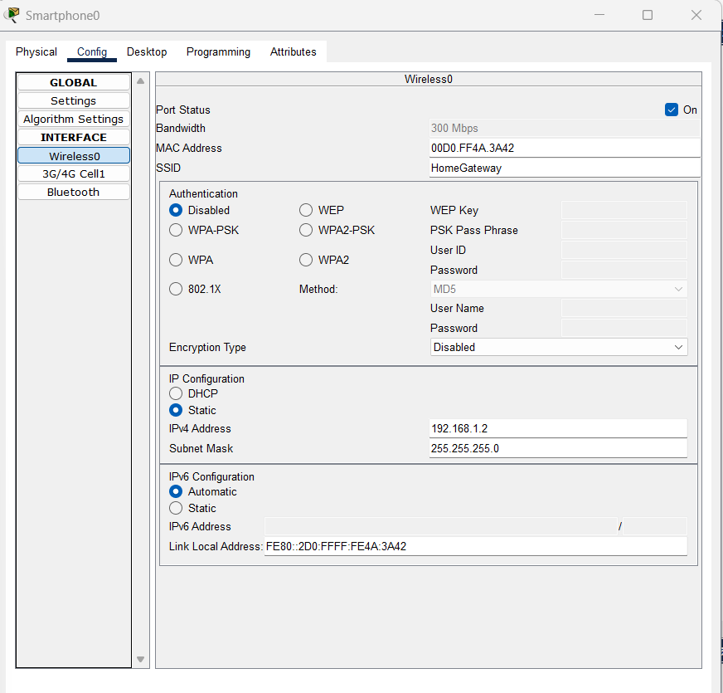

1. The connection will be automatically established

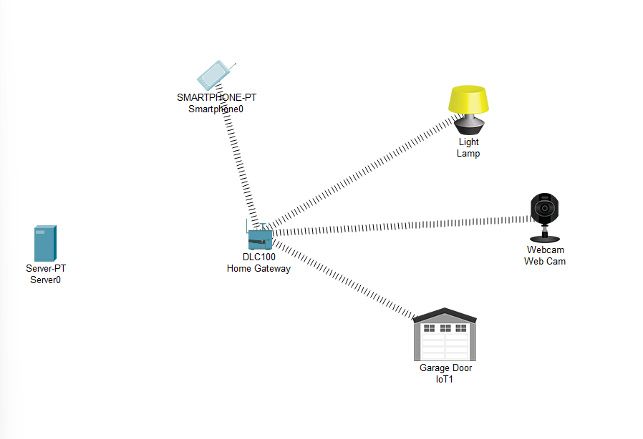

1. After that we connect the server to the Home Gateway with the help of Copper Straight wire

From fast ethernet to ethernet 1

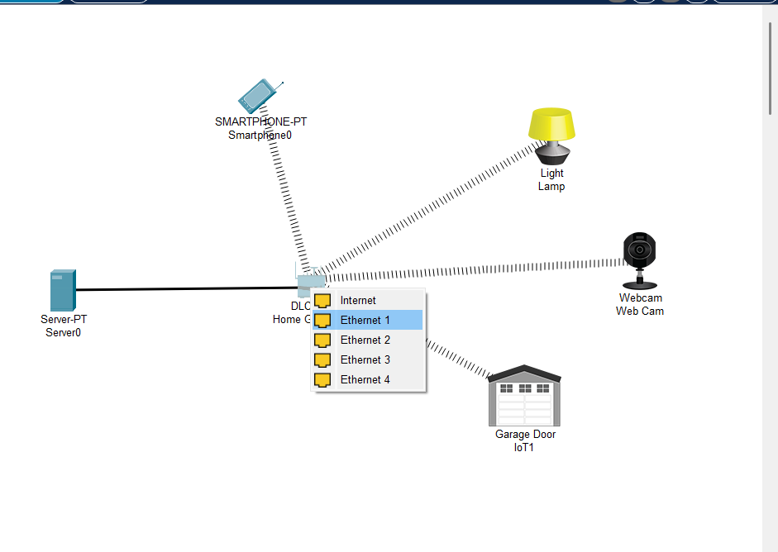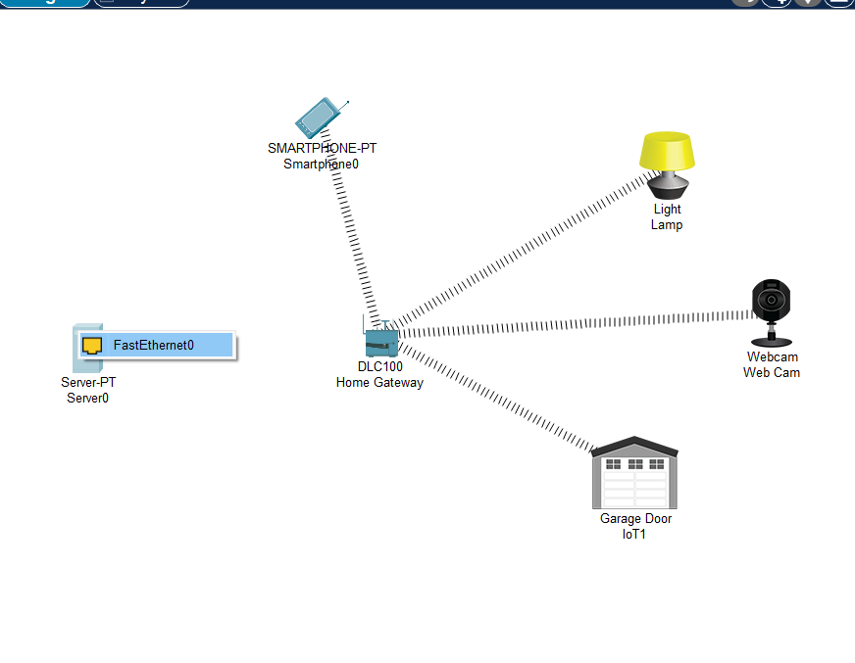

1. We assign IP Address to the Server

Click on server 🡪 IP Config 🡪 Desktop

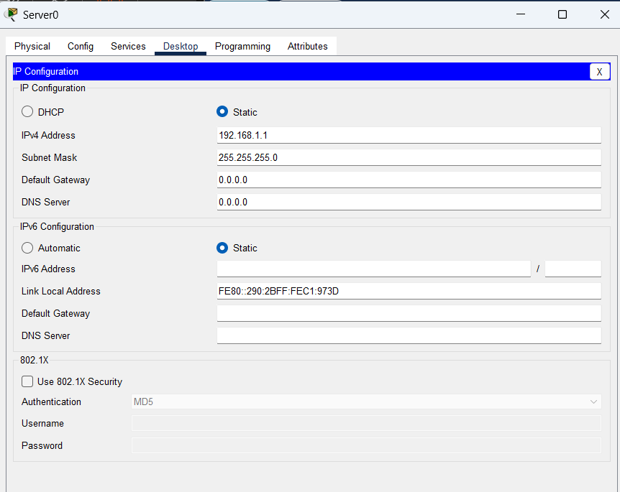

1. After that we assign the IP Address to the smart phone

Click on Smart Phone 🡪 IP Config 🡪 Desktop

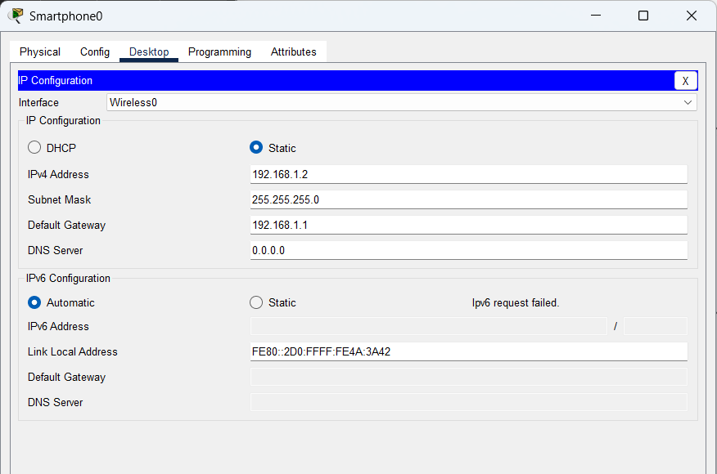

1. After that we assign the IP Address to the Light, Webcam and Garage Door

Click on Light 🡪 Config 🡪 click on Wireless 0 🡪 IP Configuration

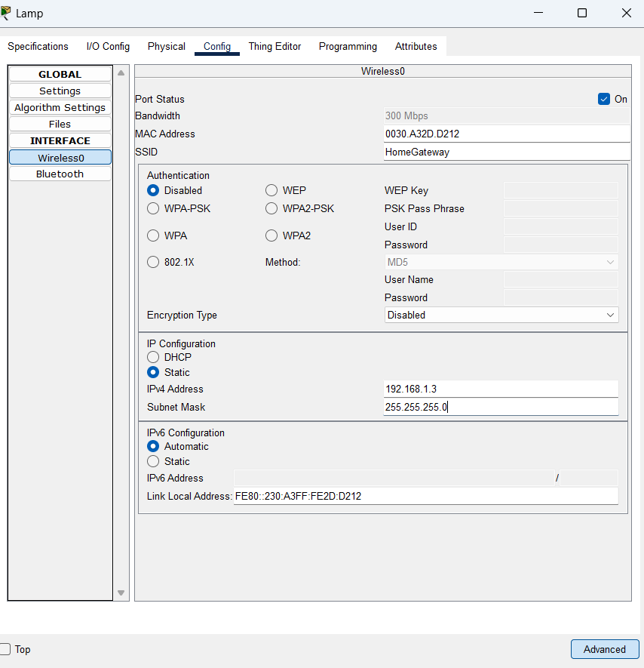

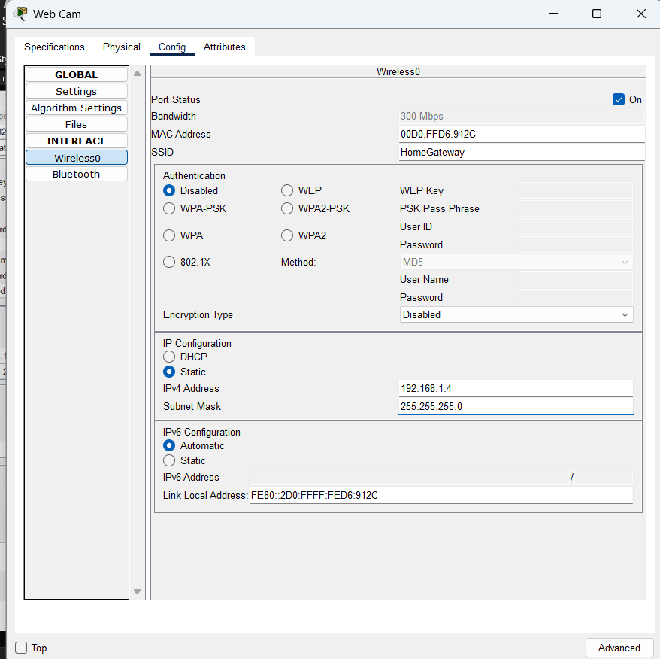

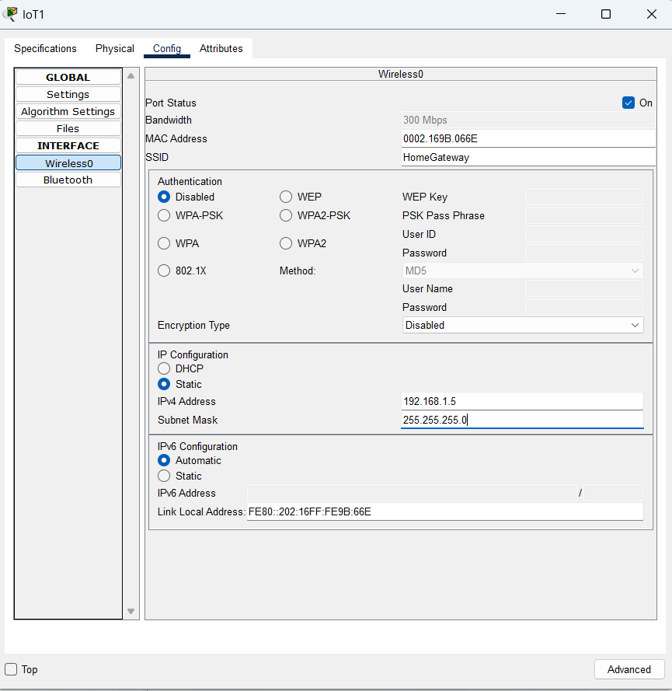

1. Then we go to the server 🡪 Services 🡪 IoT 🡪 click on ‘On’

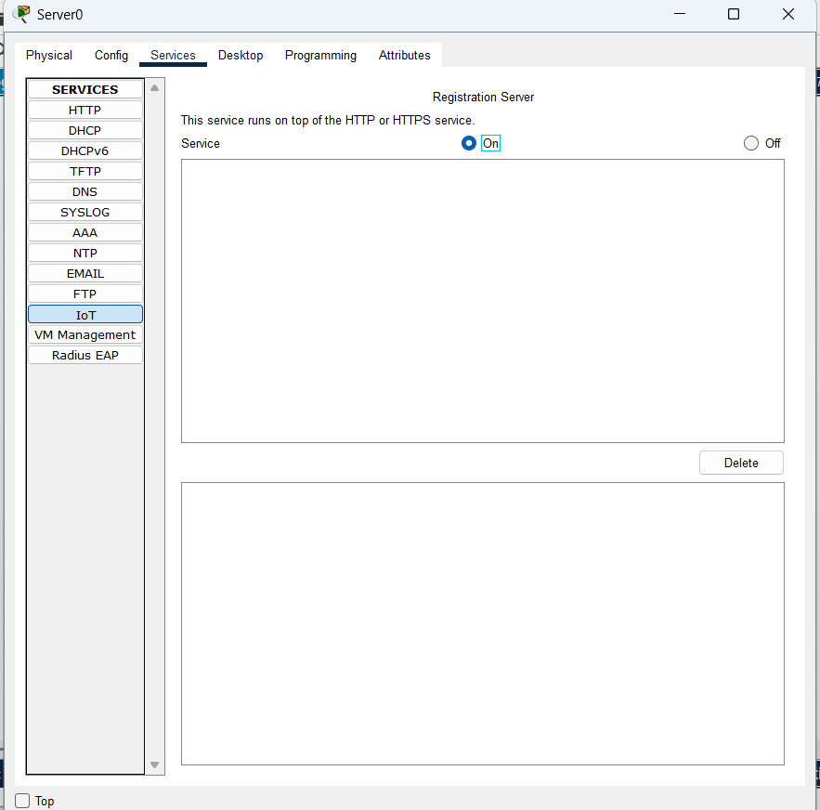

1. In server go to Desktop 🡪 Web Browser 🡪 Add IP Address of the Server And click on ‘Go’

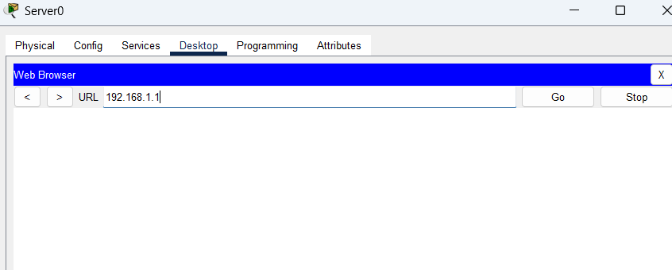

1. After that this widow will appear here we click on Sign up now to create an IoT Account

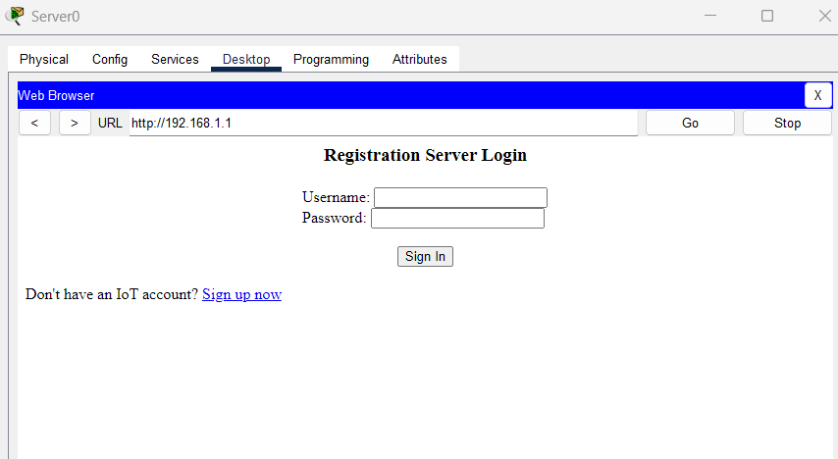

1. Add user name and password and click on create

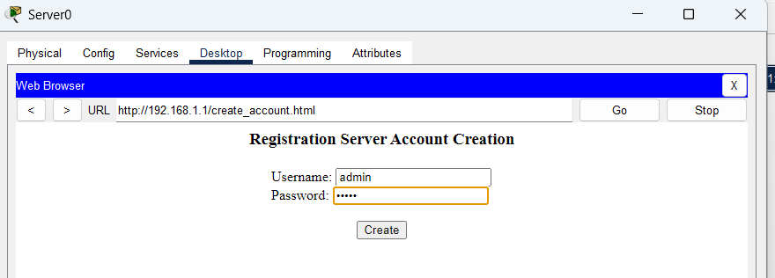

Username: admin

Password: admin

We will get this window

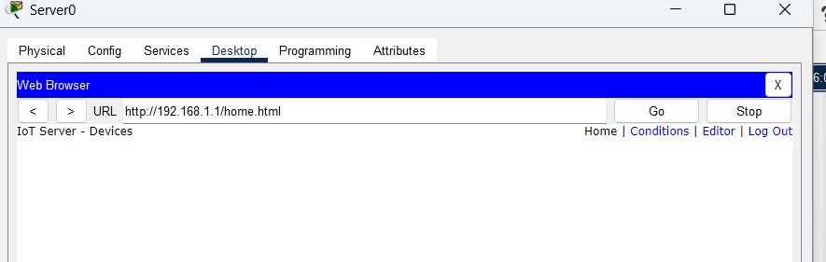

1. Now we close it and add all of the IoT Devices

Click on Light 🡪 settings 🡪 in IoT Server define remote server 🡪 User Name and Password and click on connect

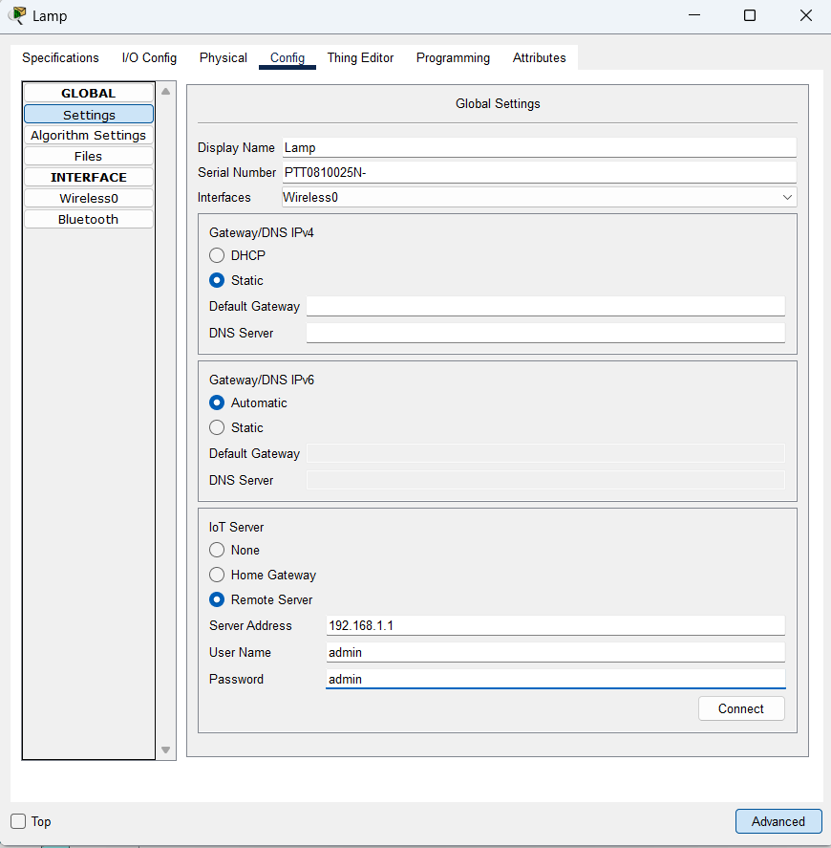

1. After clicking on connect we see refresh instead of connect the device is connected successfully

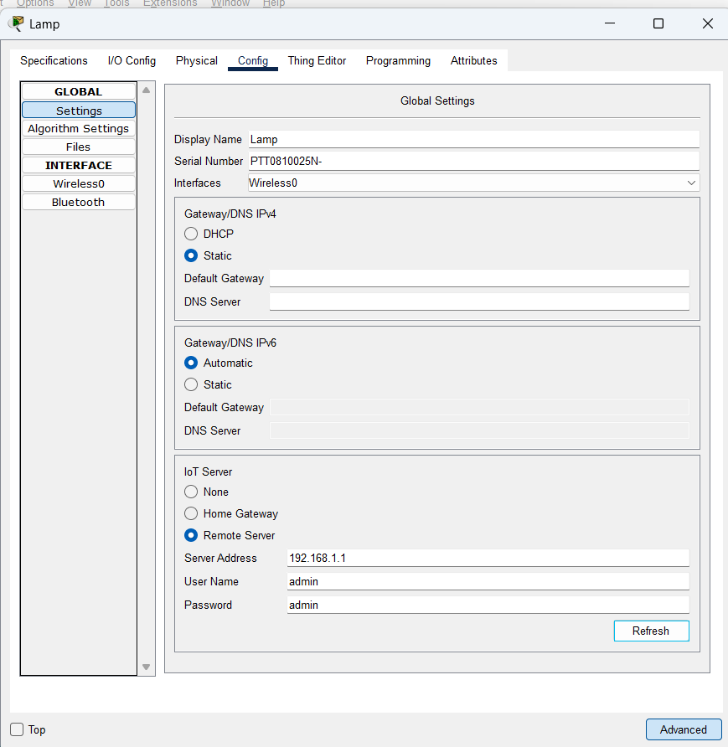

1. Do the same for Webcam and Garage Door

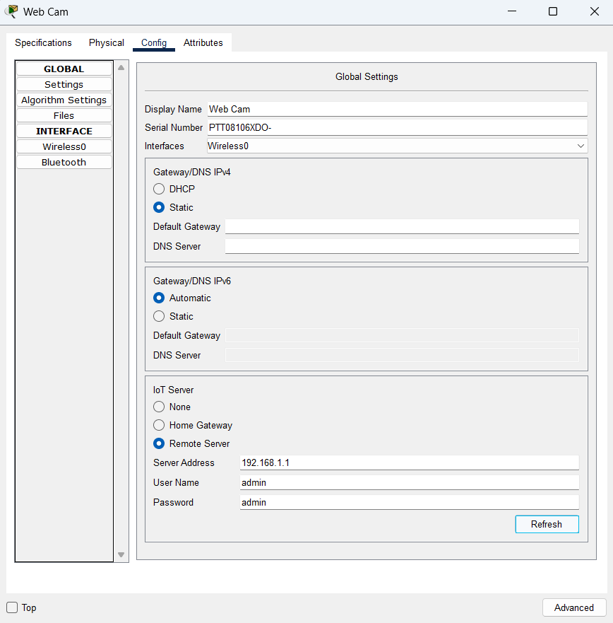

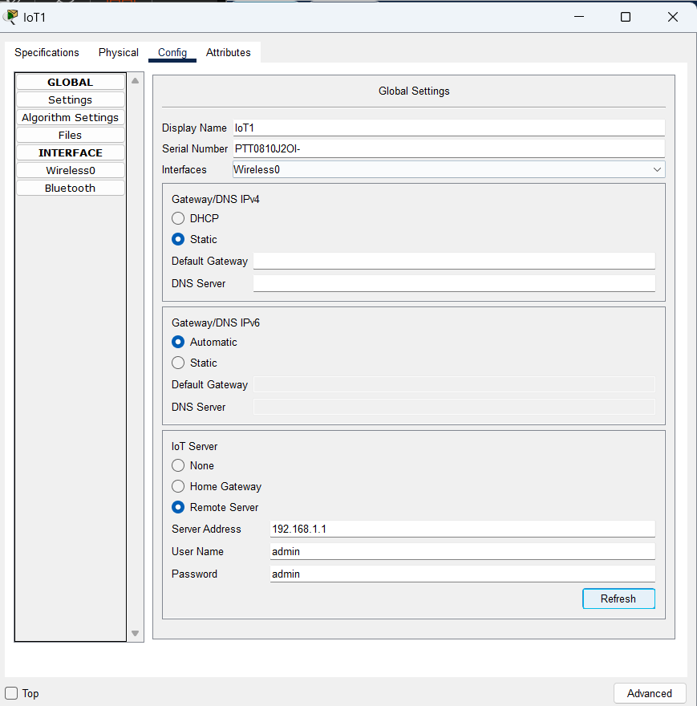

1. Now go to Smart Phone 🡪 Desktop 🡪 Web Browser 🡪 type URL of the Server and click on Go and add Username and Password and click on ‘Submit’ 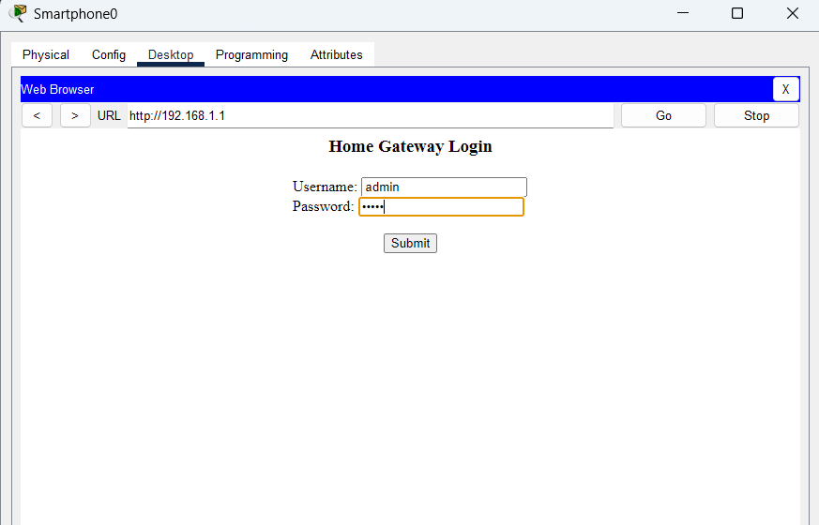

Now we will see the 3 devices is added

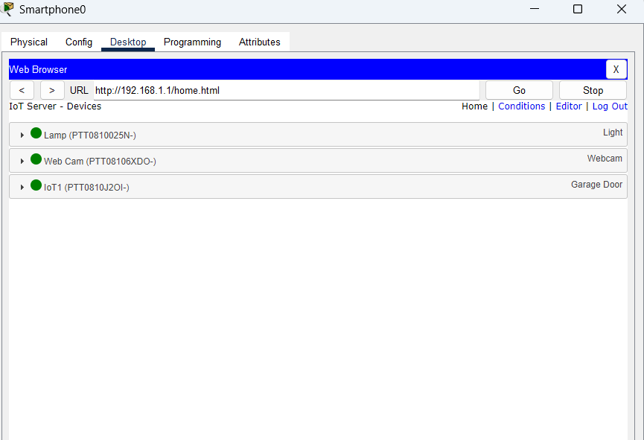

1. Now we add the conditions

Click on conditions 🡪 add

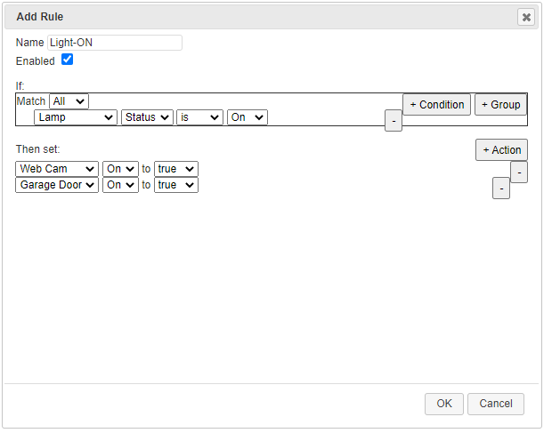

Click on Ok

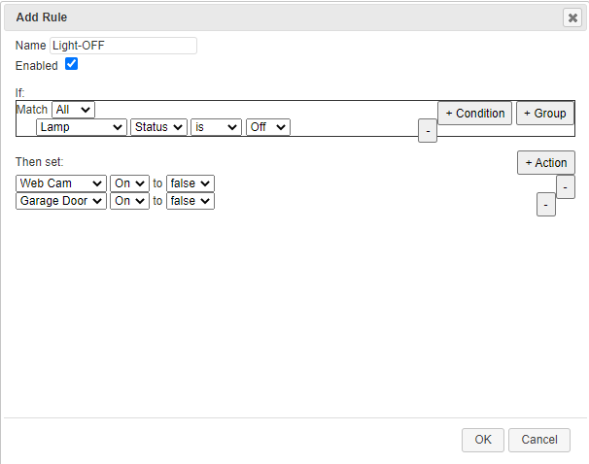

There are 2 conditions add:

1. If the light is on then the webcam and garage door is on
2. If the light is off then the webcam and garage door is off

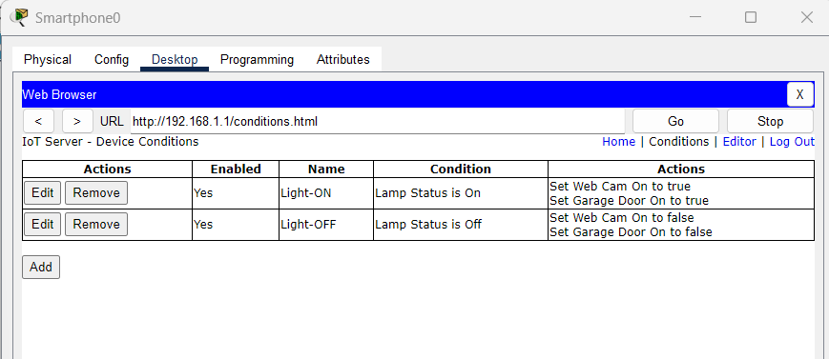

1. Now we check that the conditions is applied or not

Go to smart phone 🡪 desktop 🡪 web browser 🡪 on the light

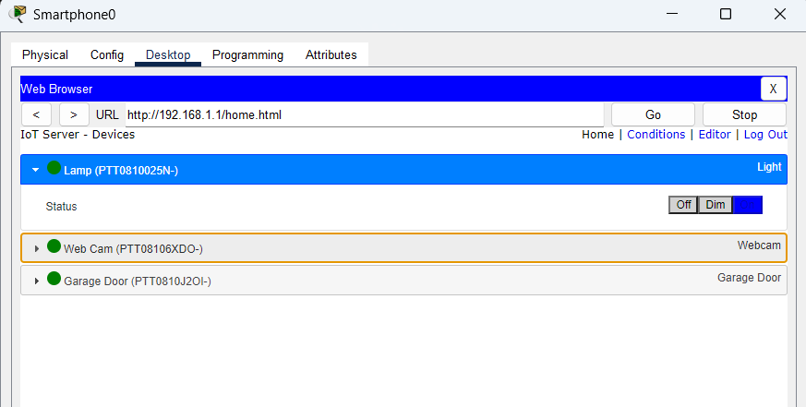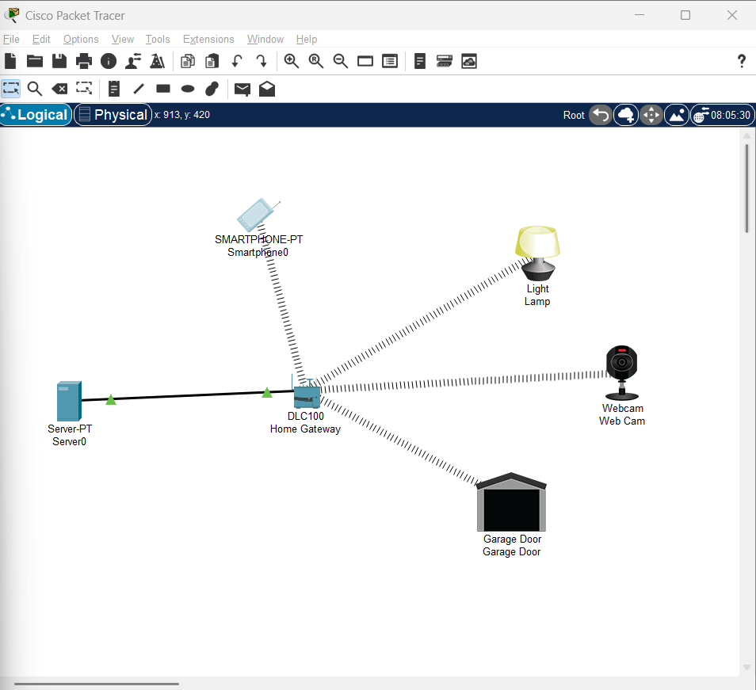

1. As we click on off the webcam and garage door is also close

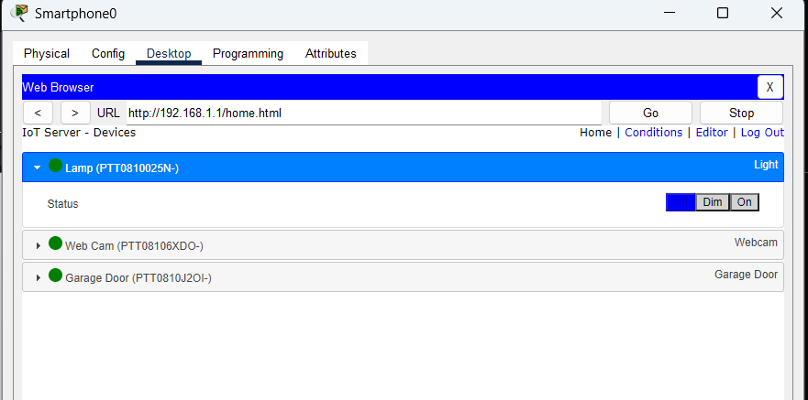

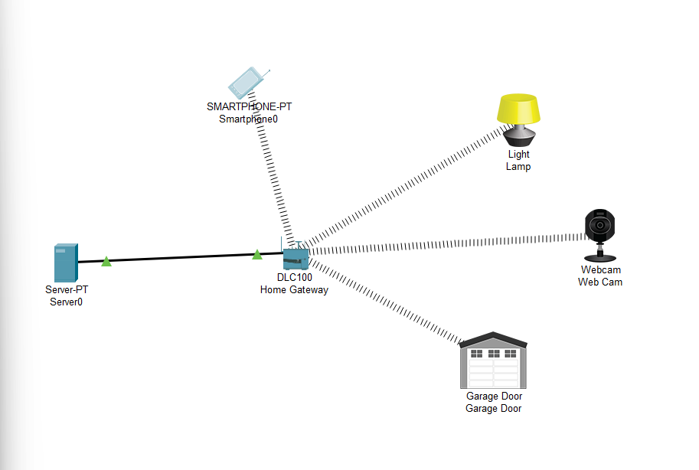

**Practical No.08**

**Date: Roll No.:19**

**Aim: Create and simulate a simple adhoc network**

**Steps:**

1. Download Omnet++ version 4.2.2 from https://omnetpp.org/omnetpp.

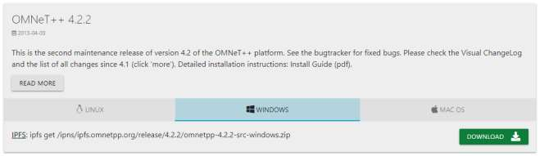

1. After downloading the zip, extract it.

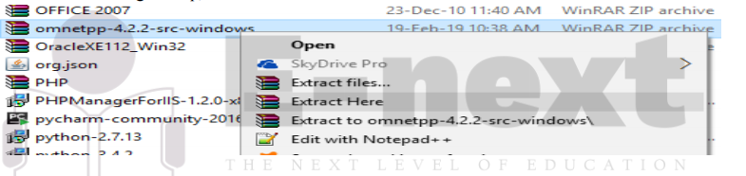

1. Now Omnetpp-4.2.2 folder has been created.
2. Open the folder and Double click on mingwenv.
3. A command prompt will open. Type the command

I. ./configure

II. make

1. When both commands get executed then omnet++ is installed in your system.

1. To check whether it is installed or not type the command omnetpp in the command prompt and omnetpp will get started. If it does not start then try to reinstall.

8. After installing Omnet++, we need to install inet framework version 2.1.0 which is specially

designed for wireless simulation. You can download inet framework from below link.

https://inet.omnetpp.org/Download.html

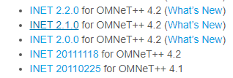

9. After downloading the Inet 2.2.0 unzip the files.

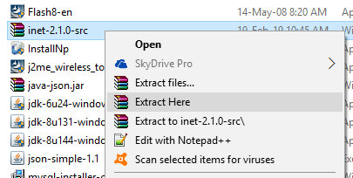

1. After extracting inet-2.1.0-src folder will be created.
2. Open the Omnet++ idle.

12. Click on File > Import. A window will appear in that click on General > Existing Projects in

Workspace.

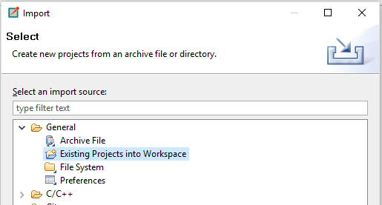

13.Click next and in the root directory browse for the inet-2.1.0-src folder which was created.

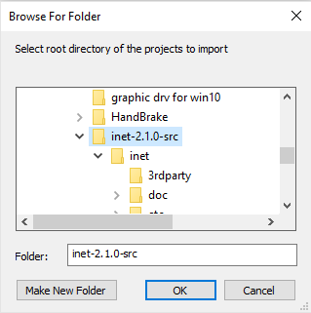

14. Click the checkbox to copy the projects into the workspace and then Finish.

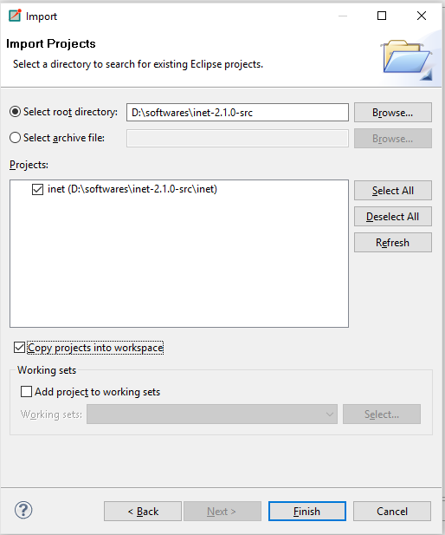

1. An Inet folder will be created in the project explorer.

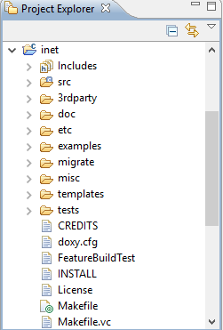

1. Expand the inet folder > examples > adhoc. Right click on adhoc > New > Folder as SimpleAdhoc

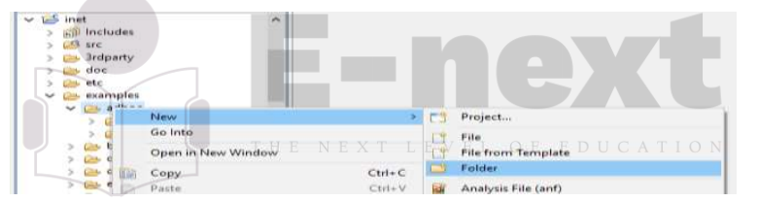

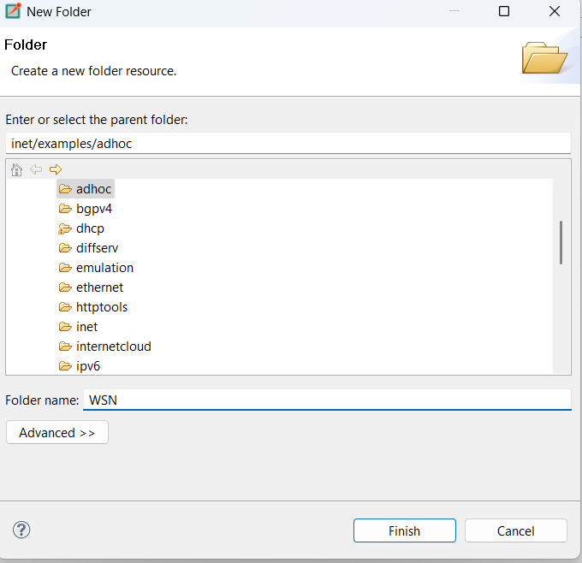

17. Right click on WSN> New > Network Description File (NED). Name the file as Net1.

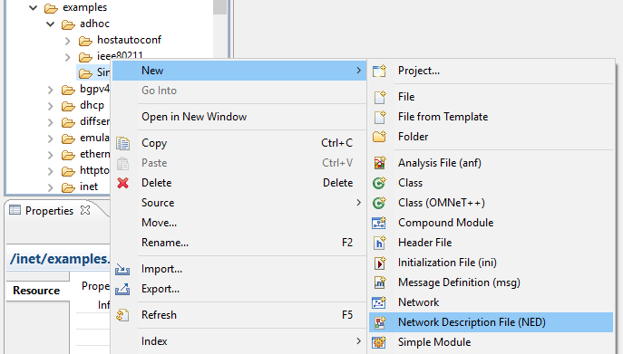

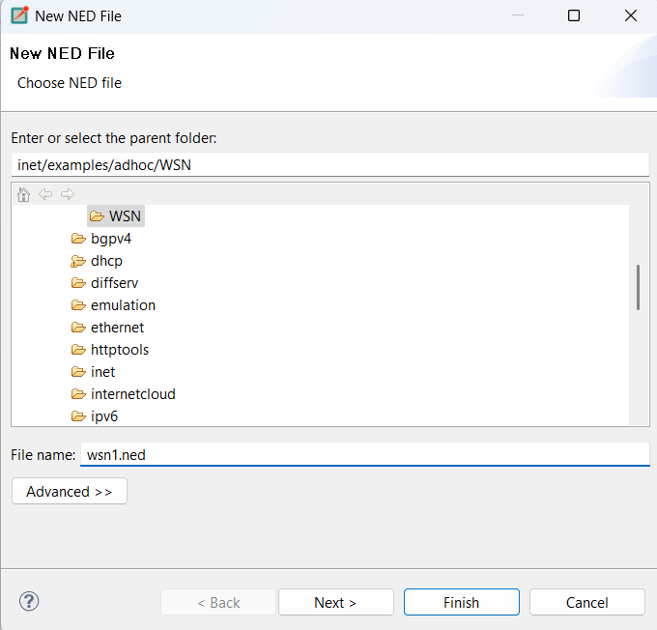 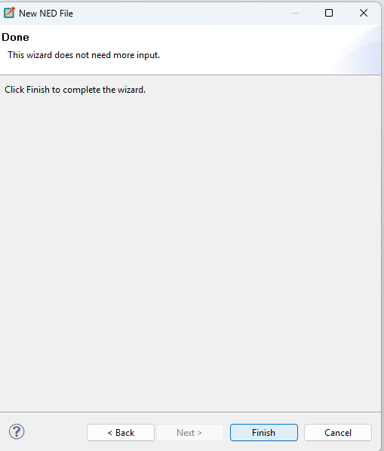

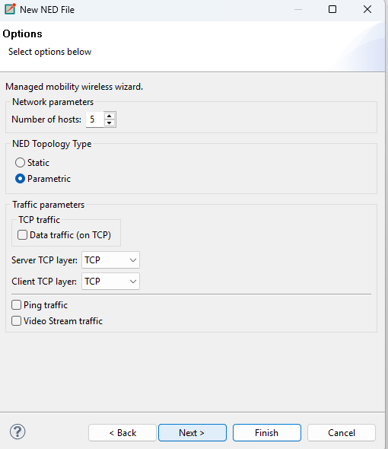

18.Select New Managed Mobility Wireless Network Wizard and Click Next.

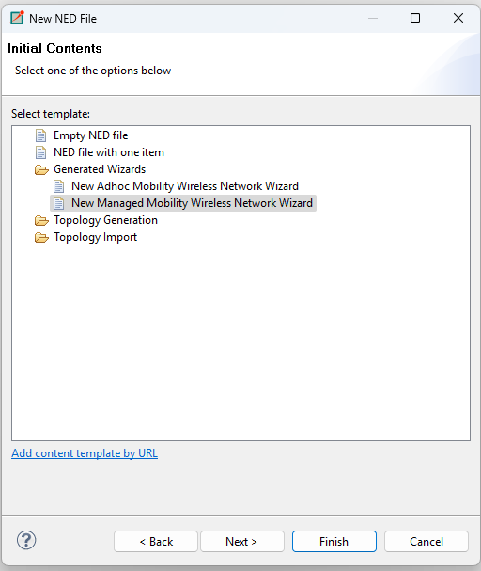

1. Configure as follow.

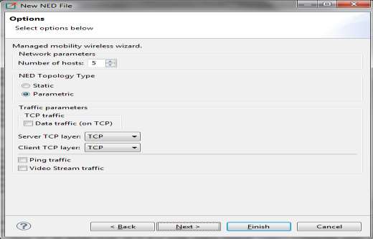

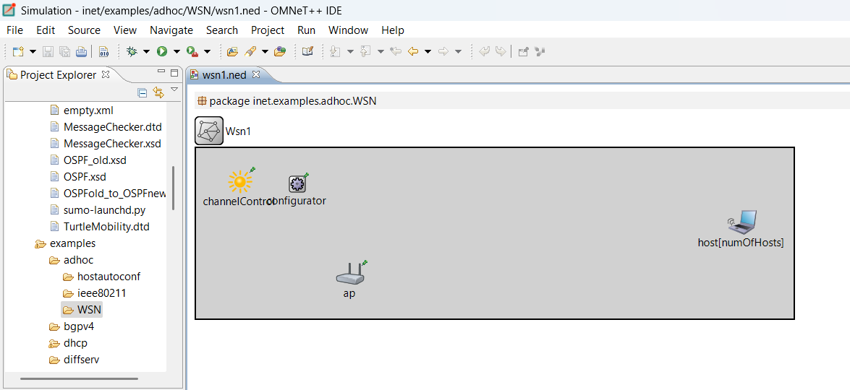

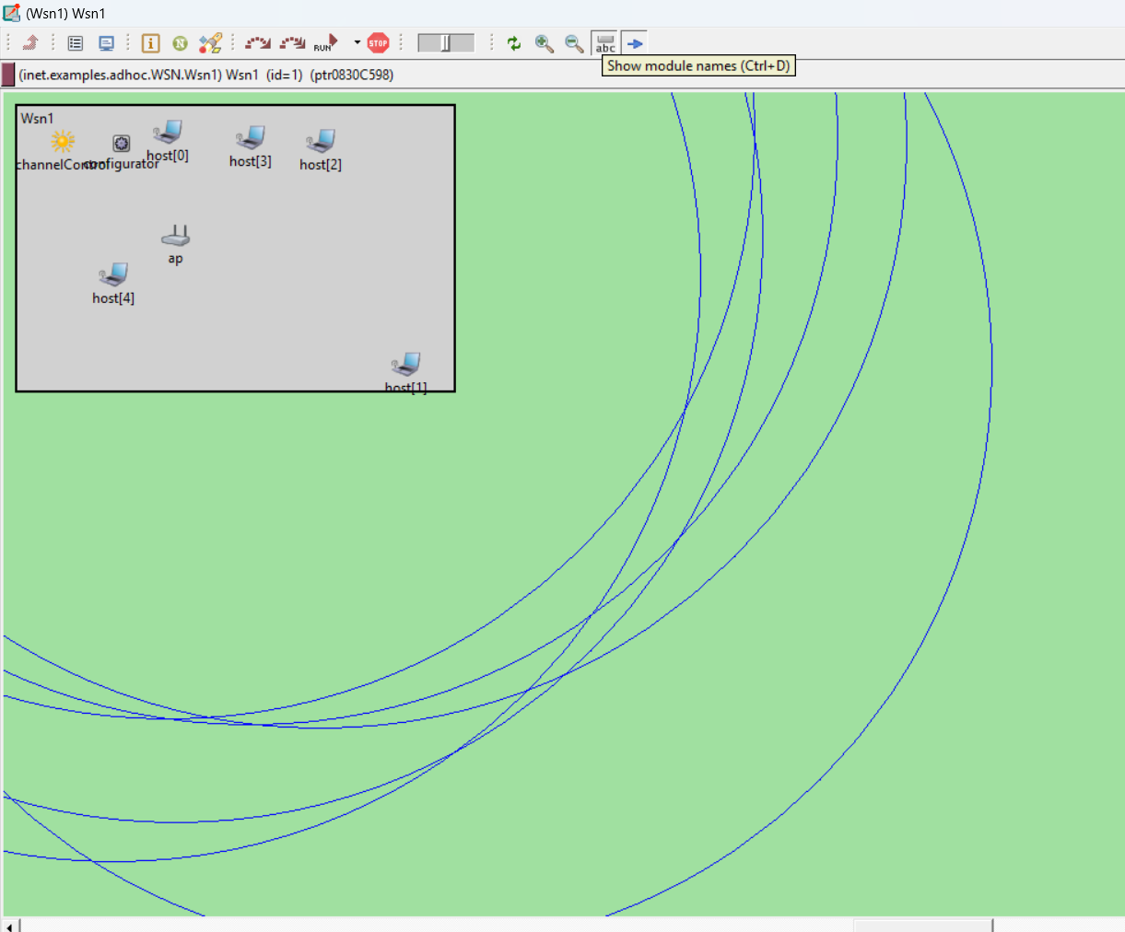 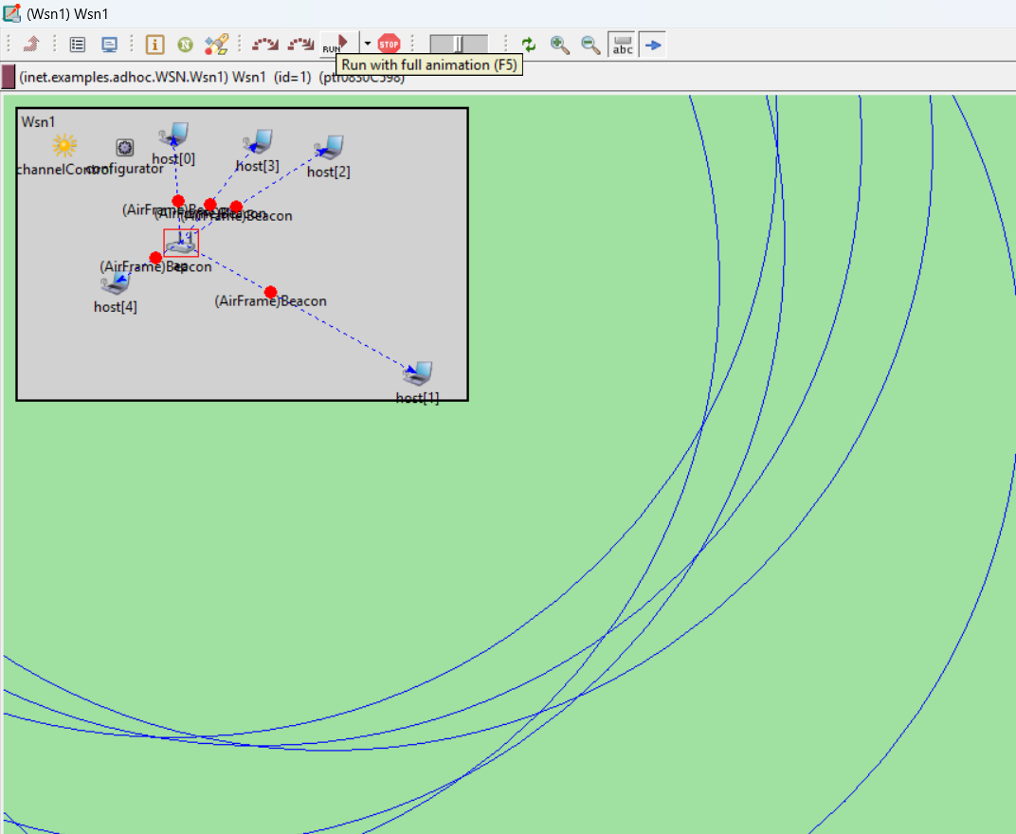

**Practical No.09**

**Date: Roll No.:19**

**Aim: Create a basic MANET implementation simulation for Packet animation and Packet Trace.**

Open inet folder in example folder Right click on manetrouting and create new folder

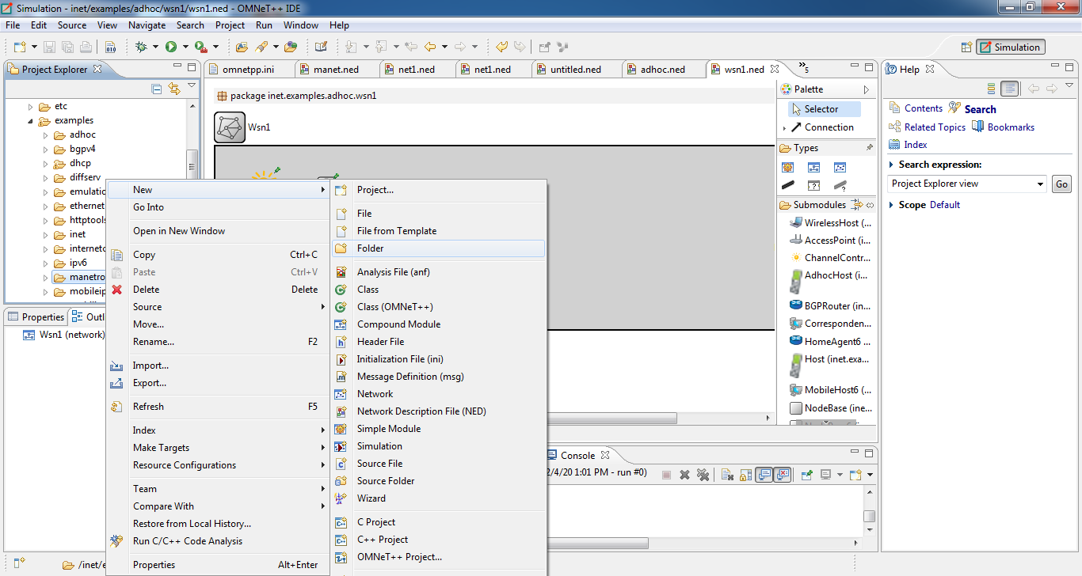

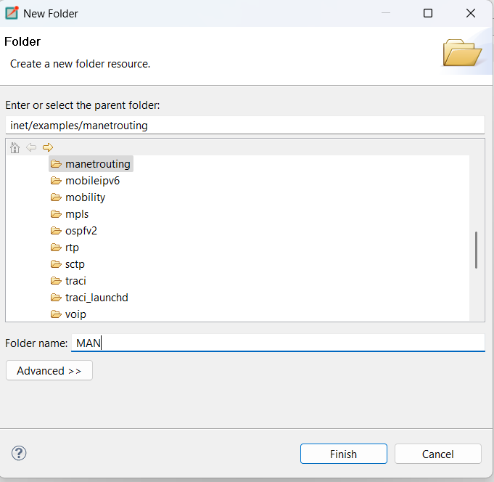

Right click on your newly created folder and select NED file.

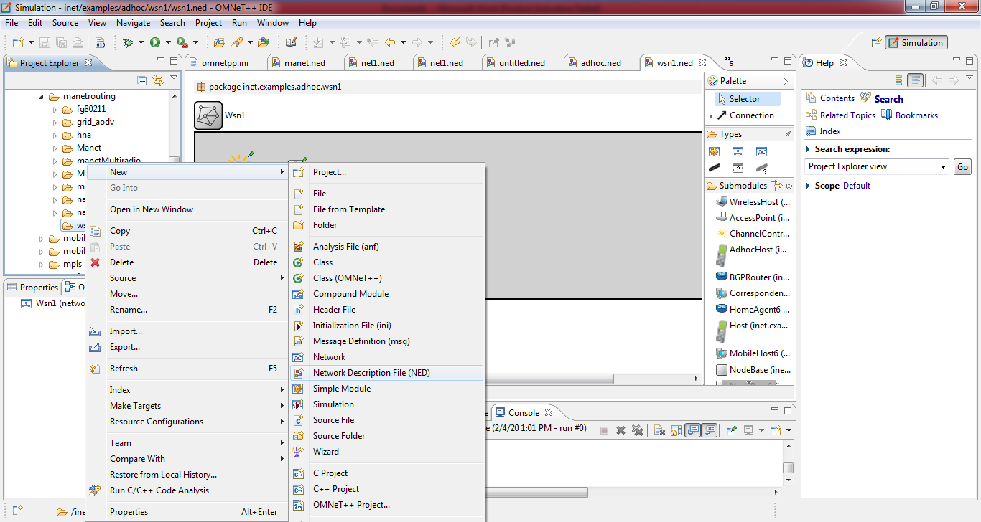

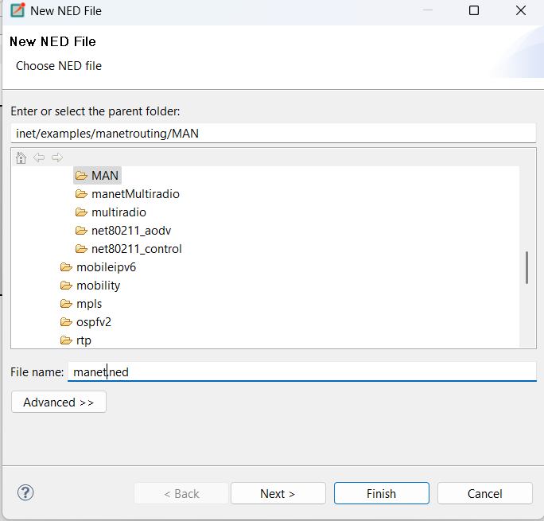

Click on new adhoc mobility wireless network wizard.

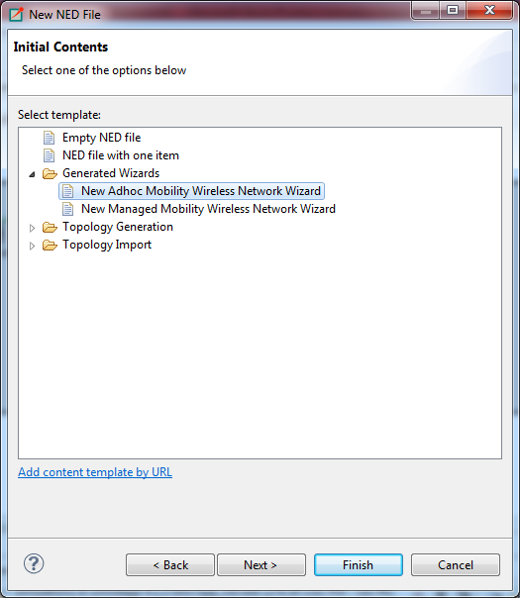

Then configure as follows:

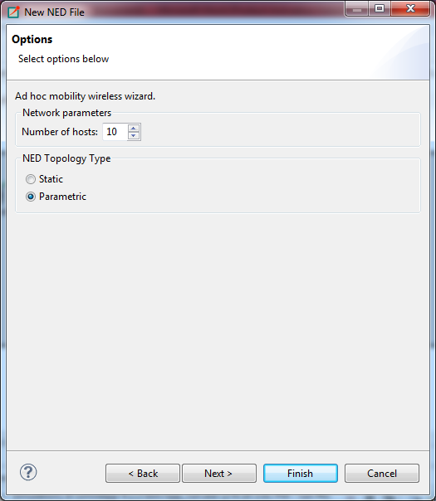

Then click on finish.

